Supplimenary Figures
Supplimenary Figure S1. The error rate of TE-Locate in pericentromeric regions. The X-axis denotes different insert sizes; the Y-axis denotes different read length; the concentric circles denote different coverage: from inner to outer circles, the coverages are 2×, 5×, 10× and 20× respectively. The red, orange, and green colors denote the proportion of false positives, false negatives and the rest. Here the false positive is defined as the ratio between false calls and all calls, the false negative is defined as the ratio between missing calls and all TEs inserted.
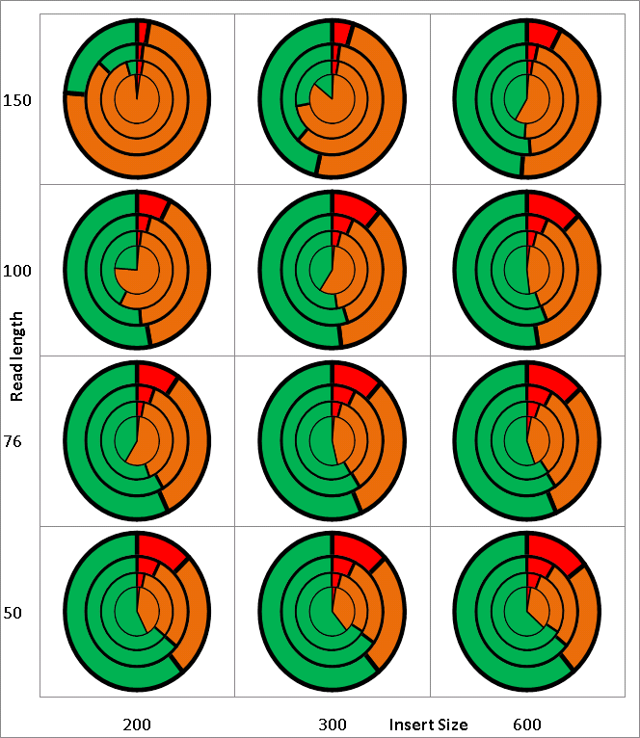
Supplimenary Figure S2. The error rate of BreakDancer in chromosomal arm regions. The X-axis denotes different insert sizes; the Y-axis denotes different read length; the concentric circles denote different coverage: from inner to outer circles, the coverages are 2×, 5×, 10× and 20× respectively. The red, orange, and green colors denote the proportion of false positives, false negatives and the rest. Here the false positive is defined as the ratio between false calls and all calls, the false negative is defined as the ratio between missing calls and all TEs inserted.
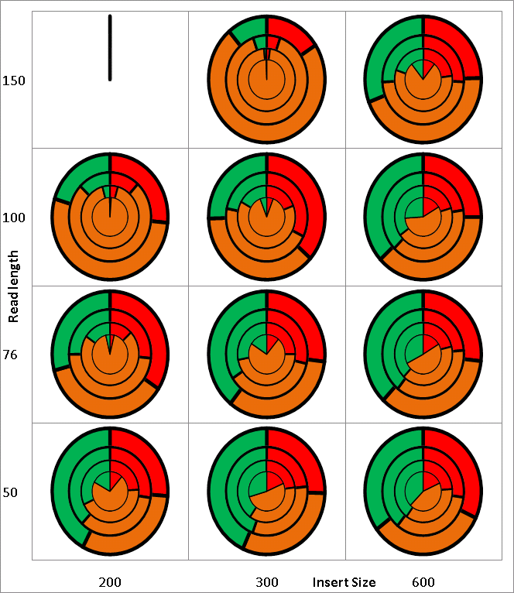
Supplimenary Figure S3. The error rate of BreakDancer in pericentromeric regions. The X-axis denotes different insert sizes; the Y-axis denotes different read length; the concentric circles denote different coverage: from inner to outer circles, the coverages are 2×, 5×, 10× and 20× respectively. The red, orange, and green colors denote the proportion of false positives, false negatives and the rest. Here the false positive is defined as the ratio between false calls and all calls, the false negative is defined as the ratio between missing calls and all TEs inserted.
