Table S1. Brassica orthologs and paralogs of Arabidopsis genes.
At gene | AGI | Syntenic ortholog | Subgenome | Non-syntenic ortholog
Pol IV subunits and associated proteins
NRPD1 | At1g63020 | Bra027611 | MF2 | Bra041010*
NRPD2 | At3g23780, At3g18090 | Bra022279, Bra021293 * | LF, MF1
NRPE1 | At2g40030 | Bra000162 | MF2
NRPD4 | At4g15950
NRPE5 | At3g57080 | Bra007300 | MF1
NRPD7 | At3g22900 | Bra023791 | MF1
NRPE7 | At4g14660 | Bra0391721 | MF2
RDR2 | At4g11130 | Bra035249 | LF
DCL3 | At3g43920 | Bra019456 | MF2
AGO4 | At2g27040 | Bra034318 | MF1
AGO6 | At2g32940 | Bra022918 | MF2 | Bra022057 *
AGO9 | At5g21150 | Bra002360/Bra002361, Bra020152 | LF, MF2
CLSY1 | At3g42670 |  |  | Bra021058
DRD1 | At2g16390 | Bra013077 | MF2
DRM2 | At5g14620 | Bra08749, Bra023479 */  Bra023480 * | LF, MF2
KTF1 | At5g04290 | Bra009470 | LF
Pol II genes
NRPB1 | At4g35800 | Bra010510 | MF2
NRPB2 | At4g21710 | Bra013550, Bra038761, Bra020873/Bra020874 * | LF, MF1, MF2 | Bra020911
NRPB4 | At5g09920 | Bra009073, Bra006039, Bra028609 | LF, MF1, MF2 | Bra039605 *
NRPB5 | At3g22320 | Bra031350, Bra001864 | LF, MF2
NRPB7 | At5g59180 | Bra002591, Bra006732, Bra020336 | LF, MF1, MF2 | Bra024065
Other RNA silencing genes
RDR1 | At1g14790 | Bra026187 | LF
RDR6 | At3g49500 | Bra029957 | MF1
DCL1 | At1g01040 | Bra033293 | LF
DCL2 | At3g03300 | Bra031999 | LF
DCL4 | At5g20320 | Bra002293 | LF
AGO1 | At1g48410 | Bra032254 | MF2
AGO2 | At1g31280 | Bra023172 | LF | Bra040815
AGO7 | At1g69440 | Bra003999 | MF2
AGO10 | At5g43810 | Bra033698, Bra027505 * | LF, MF2 | Bra014136
* Partial gene.

Figure S1. Confirmation of putative TILLING mutants. Schematic of the BrNRPD1 genomic region surrounding the brnrpd1-1 and brnrpd1-2 mutations with examples of CAPS/dCAPS marker results (M, homozygous mutant; H, heterozygous; W, wild type).
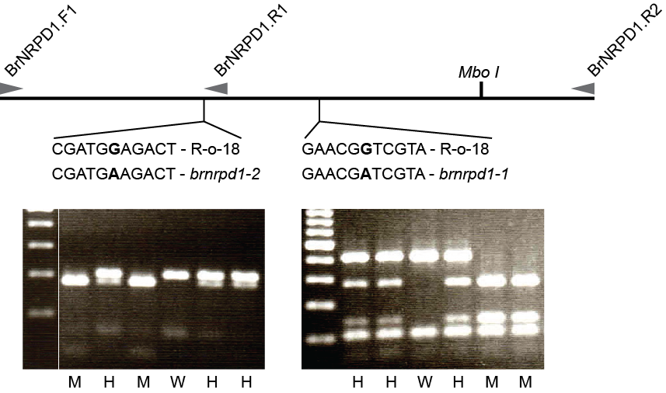

Figure S2. Chromosomal distribution of Pol IV-dependent and -independent loci. Number of Pol IV-dependent (0-25) and Pol IV-independent (>100) siRNA-producing windows in a 1Mb bin (rolling average of 3 bins) across the ten B. rapa and 5 Arabidopsis chromosomes.
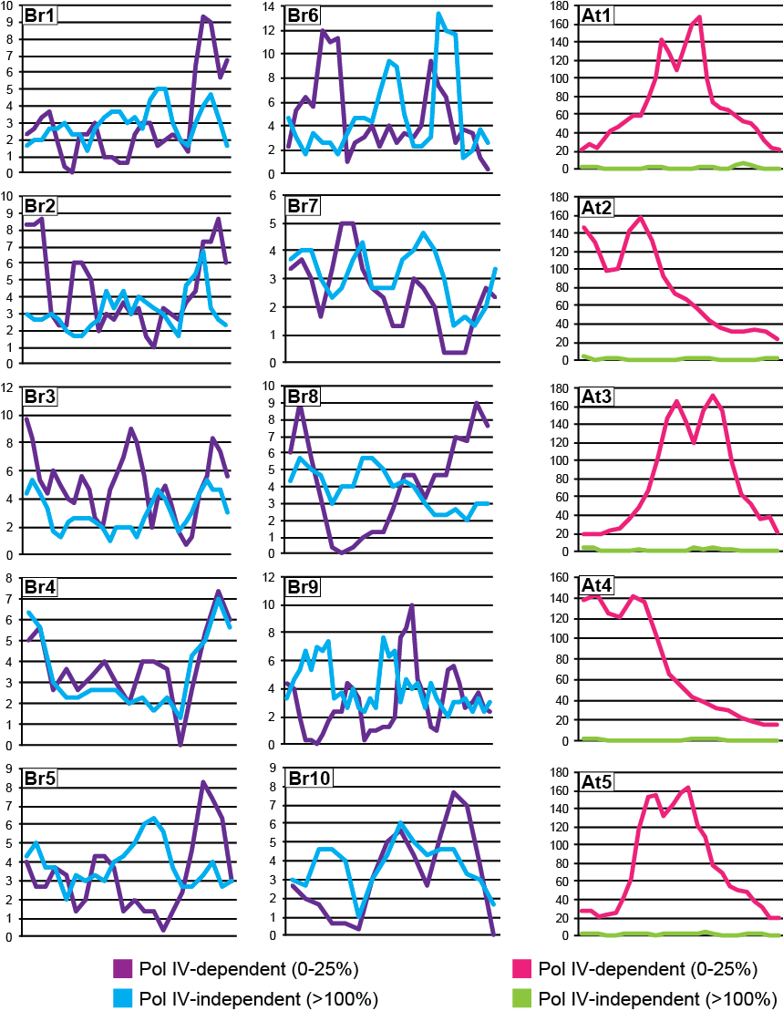

Figure S3. Correlation between brnrpd1-1 and brnrpd1-2 mutants. Relative abundance (HNA brnrpd1-1/HNA R-o-18) was calculated for each sRNA-producing window and averaged within the Pol IV-dependency groups established in Figure 4A.
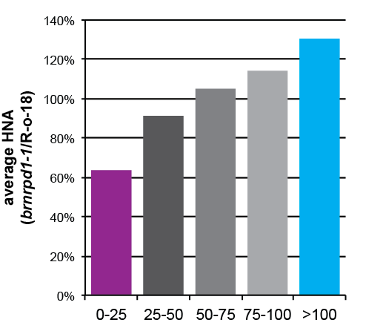
Figure S4. Genomic loci producing sRNAs. Genomic annotations overlapping
sRNA-producing windows in B. rapa. Windows overlapping more than one genomic feature were assigned a single annotation based on miRNA > t/r/snRNA > TE > gene.
