Supporting Information
Table S1. Primary root % growth on 0.3 mM CsCl compared to the control condition. Primary root lengths of the seedlings grown on 0.5 mM KCl with or without cesium for
7 days were measured and the % growth was calculated for Col-0, ipt1,3,5,7, ahk2;3, ein2-1, ers1-1, aux1-7, jar1-1, Ler (wild type for rga24;gait6) and rga24;gait6. Standard error
(n ≥ 18) and P-values compared to each wild type are indicated.
 | Growth % | SE | P-value
Col-0 | 61.07 | 1.65
ipt1,3,5,7 | 72.41 | 2.67 | <0.01
ahk2;3 | 72.79 | 3.88 | <0.01
Col-0 | 65.61 | 1.21
ers1-1 | 73.33 | 2.51 | >0.05
ein2-1 | 73.87 | 3.81 | <0.05
aux1-7 | 80.30 | 3.56 | <0.001
jar1-1 | 81.42 | 2.38 | <0.001
Ler | 87.98 | 1.54
rga24;gait6 | 110.68 | 1.93 | <0.001
Figure S1. (A) K⁺ contents in Col-0, aos and coi1-16 grown on 1.75 mM KCl with (white bars) or without (black bars) 0.3 mM CsCl for 12 days; (B) Cs⁺ contents in Col-0, aos and coi1-16 grown on 1.75 mM KCl with (dotted bars) or without 0.3 mM CsCl for 12 days. Error bars indicate standard error for three biological replicates. Each sample contained more than 15 seedlings. b.d. indicates below the detection limit.
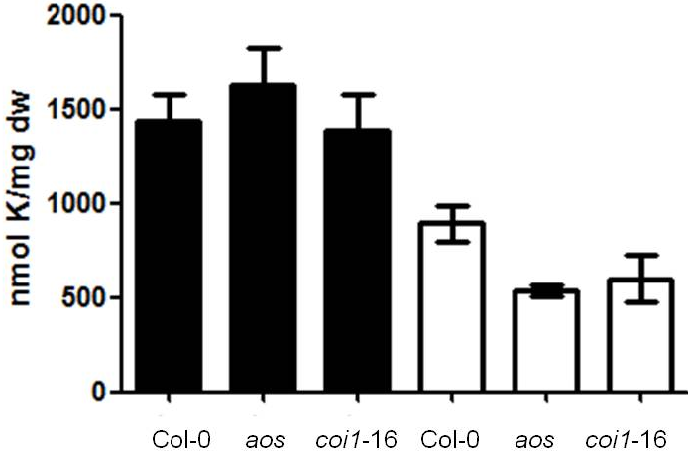 | 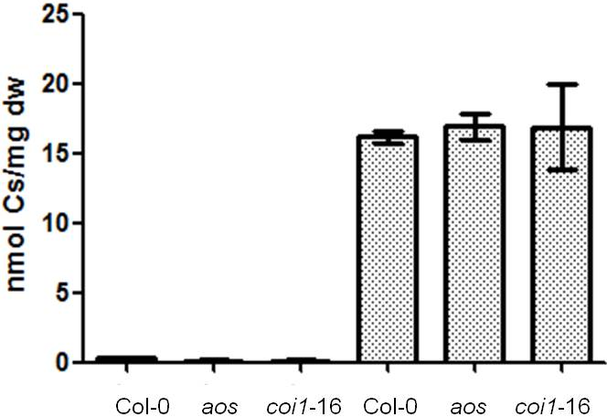
(A) | (B)

Figure S2. Gene expression of PDF1.2 and VSP2 in aos, grown on 1.75 mM KCl with or without 0.3 mM CsCl for 7 days. Values are log₂ ratios relative to the control. Error bars indicate standard error for three technical replicates. Each sample contained more than
15 seedlings.
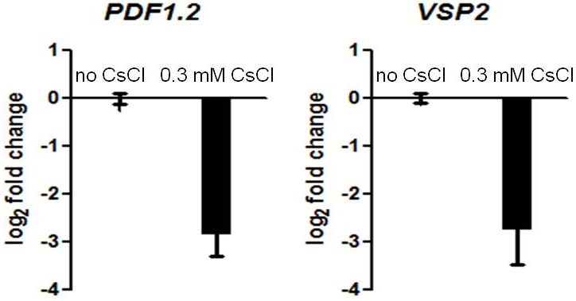
Table S2. Chemiluminescence intensity of HAK5promoter::LUC plants grown on 1.75 mM KCl with or without 0.3 mM CsCl and 2.5 μM MeJA for 11 days (cf. Figure 5 for imaging). Values are counts per second (cps) obtained using IndiGo software (Berthold).
Treatment | Overall cps
no CsCl | 519
0.3 mM CsCl | 6767
2.5 μM MeJA | 38
0.3 mM CsCl + 2.5 μM MeJA | 20
Figure S3. Gene expression of HAK5 in Col-0 roots, grown on 1.75 mM KCl with or without 0.3 mM CsCl and 2.5 μM MeJA for 11 days. Values are log₂ ratios relative to the control. Error bars indicate standard error for three technical replicates. Each sample contained more than 15 seedlings.
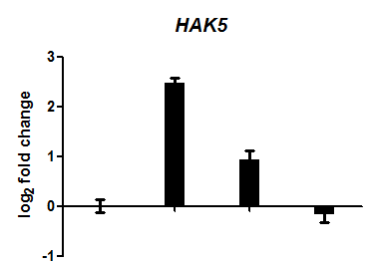
no CsCl
0.3 mM CsCl
0.3 mM CsCl + 2.5 μM MeJA
2.5 μM MeJA

Figure S4. Chemiluminescence imaging of HAK5promoter::LUC plants grown on
0.5 mM KCl with or without 0.3 mM CsCl for 7 days. Pseudo colour represents the intensity of chemiluminescence. (A) 0.5 mM KCl; (B) 0.5 mM KCl + 0.3 mM CsCl.
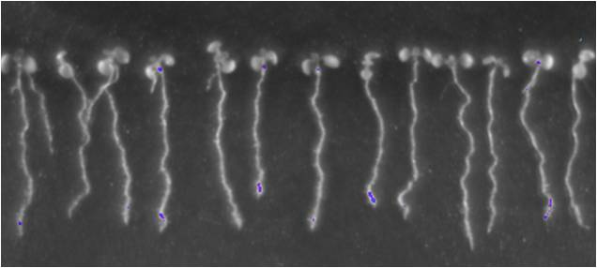
(A)
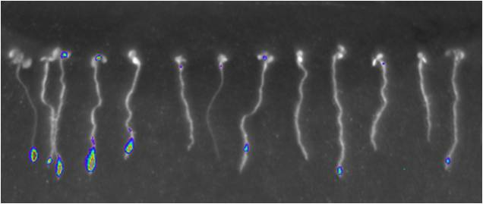
(B)
© 2013 by the authors; licensee MDPI, Basel, Switzerland. This article is an open access article distributed under the terms and conditions of the Creative Commons Attribution license (http://creativecommons.org/licenses/by/3.0/).

