Supporting Information

Syntheses of l Molecule
4'-([2,2':6',2''-Terpyridine]-4'-yl)-[1,1'-biphenyl]-4-carboxylic: 30% NH₃ solution (1 mL) and NaOH (0.054 g, 1.26 mmol) dissolved in a minimum amount of water were added slowly to a solution of methyl 4'-formyl-[1,1'-biphenyl]-4-carbonxylate (0.15 g, 0.63 mmol) and 2-acetylpyridine (0.14 mL, 1.26 mmol) in ethanol (25 mL). After the addition of the NaOH, the solution turned yellow and after about 1 h lucid brownish red. The solution was stirred vigorously at room temperature in a flask open to air for 24 h, after which water
(50 mL) was added to the solution, a slightly yellow precipitate was obtained. HCl was added to the solution, which was then neutralized alkali to pH = 5. The precipitate was collected by filtration and washed with water. For further purification it was refluxed for 1 h in 25 mL EtOH, and the solid collected by filtration and dried in vacuum. (0.045 g, 20%).

Scheme S1. l Molecule synthesis.
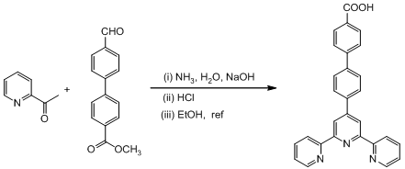
Figure S1. Characterization of l Molecule. Interrelated maps of l molecule as follows:
¹H NMR of l molecule (400 MHz, DMSO); ¹H NMR (400 MHz, DMSO): δ 13.03 (s, 1H, COOH), 8.80 (s, 4H, H^{6A}, H^{3B}), 8.71 (d, J = 6.9 Hz, 2H, H^{3A}), 8.17–8.03 (m, 6H, H^{3D}, H^{2D}, H^{3C}), 8.03–7.96 (m, 2H, H^{2C}), 7.96–7.87 (m, 2H, H^{4A}), 7.56 (d, J = 2.2 Hz, 2H, H^{5A}).
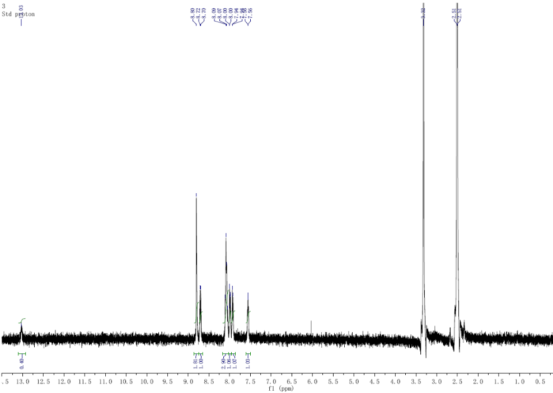

Figure S2. Thermo gravimetric curve of l molecule.
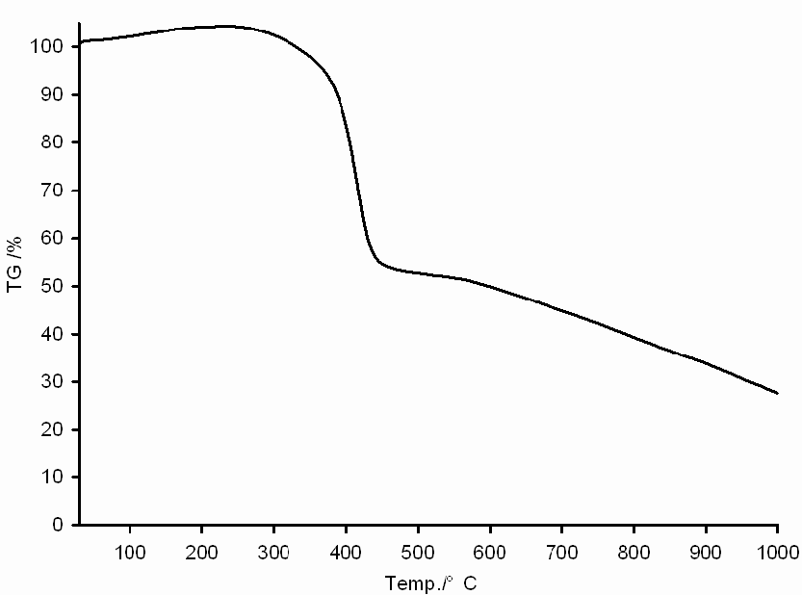

Figure S3. Infrared spectroscopy of l molecule.
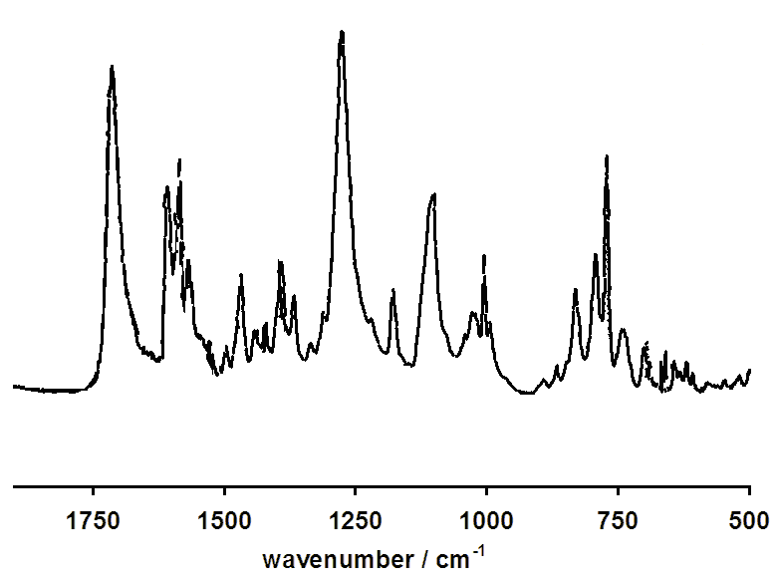
© 2013 by the authors; licensee MDPI, Basel, Switzerland. This article is an open access article distributed under the terms and conditions of the Creative Commons Attribution license (http://creativecommons.org/licenses/by/3.0/).

