Supporting Information
Figure S1. View of the two types of cages in the MOF structure made by reaction of Zr₆O₄(OH)₄(OMc)₁₂ clusters with muconic acid. Reproduced with permission from [104]. Copyright 2010 The Royal Society of Chemistry.
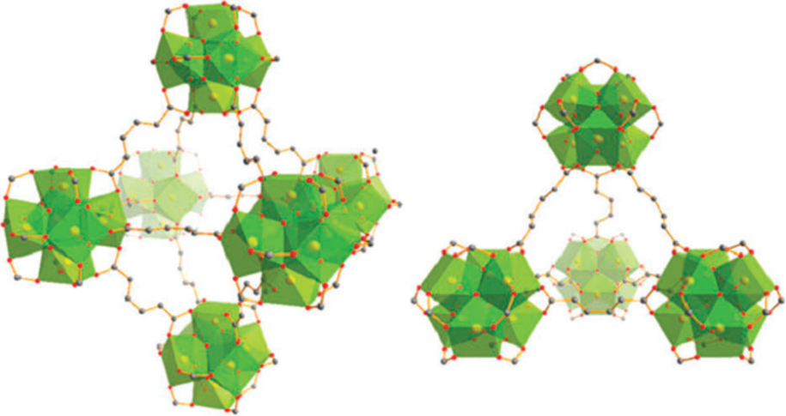
Figure S2. Illustration for the preparation of a macro-mesoporous TiO₂-graphene composite film. Reprinted with permission from [132]. Copyright 2011 American Chemical Society.
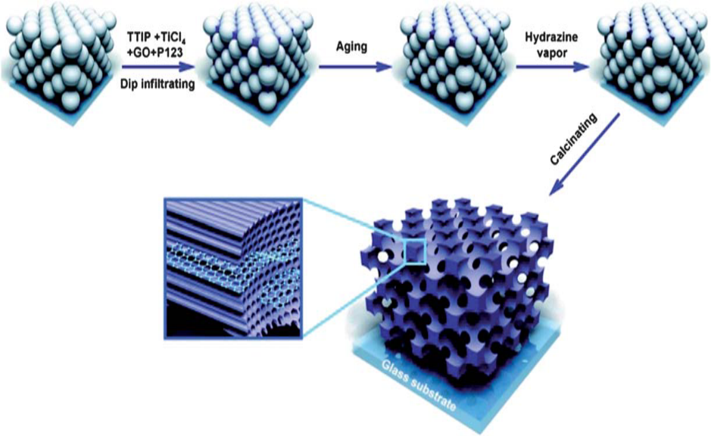
Figure S3. Schematic representation of (a) Pen and (b) its interacting group. Reprinted with permission from [153]. Copyright 2012 Elsevier.
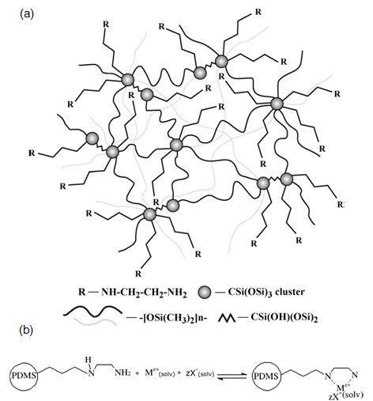
Figure S4. Adsorption of Cd²⁺ (◊) and Ni²⁺ (□) from their binary mixtures at (a) pH = 5 and (b) pH = 2. Reprinted with permission from [195]. Copyright 2007 American Chemical Society.
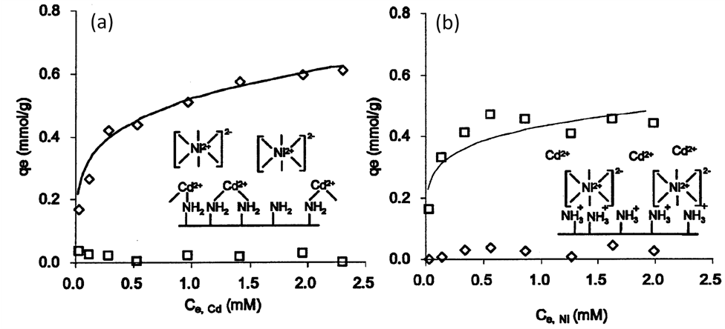
Figure S5. Schematic structure of CTS-g-PAA/APT composite. Reprinted with permission from [214]. Copyright 2009 Elsevier.
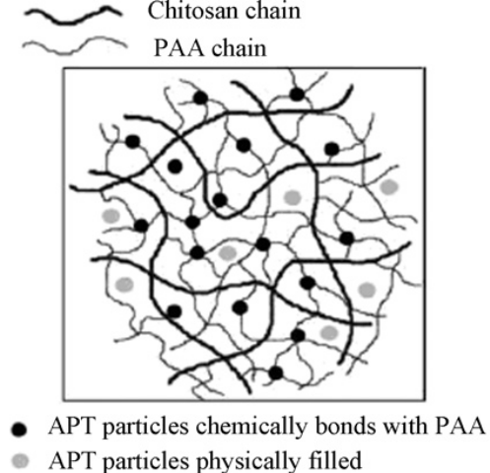
Figure S6. Schematic structure of of CTS-g-PMAA/Bent. Reprinted with permission
from [216]. Copyright 2012 Elsevier.
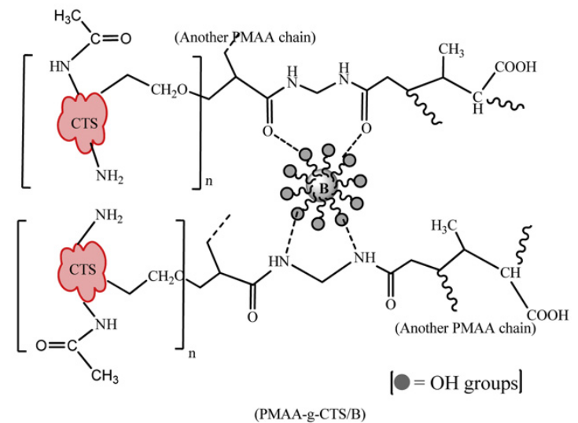
Figure S7. The distribution of different species of Cu(II) at concentration of 6.0 × 10⁻⁴ M in 0.01M NaClO₄ and CO₂-free solutions at 25 °C. Reprinted with permission from [224]. Copyright 2005 Elsevier.
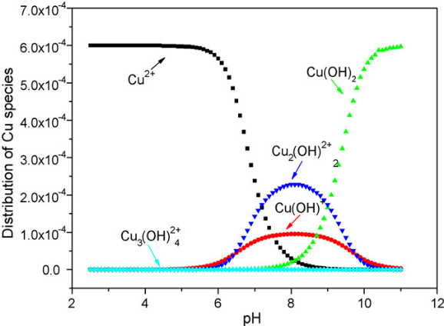
Figure S8. SEM images of (a) silica gel; (b) SG–PS–NH₂ and (c) SG–PS–azo–SA. Reprinted with permission from [233]. Copyright 2010 Springer Science and Business Media.
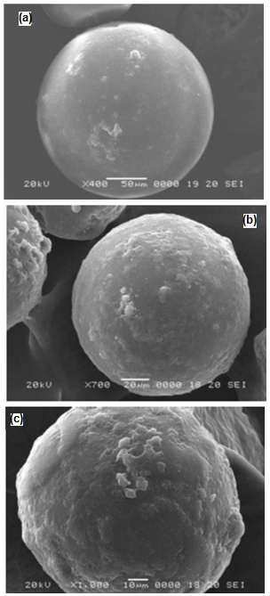
Figure S9. DSC analysis of (a) CS; (b) silica gel and (c) chitosan-grafted silica gel. Reprinted with permission from [239]. Copyright 2007 Elsevier.
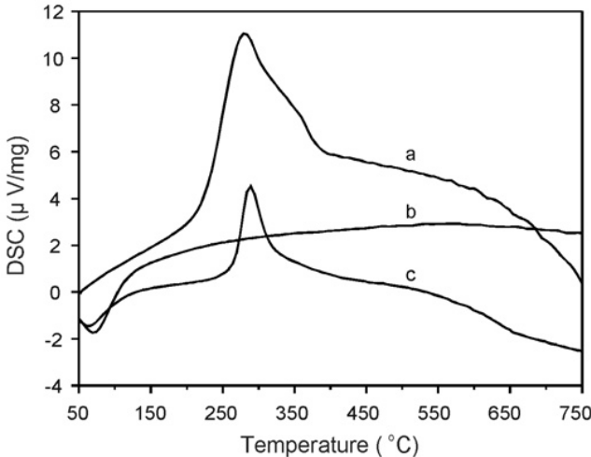
Figure S10. XRD patterns of GO nanosheets, PANI nanorods, PANI/GO
nanocomposites. Reproduced with permission from [253]. Copyright 2013 The Royal Society of Chemistry.
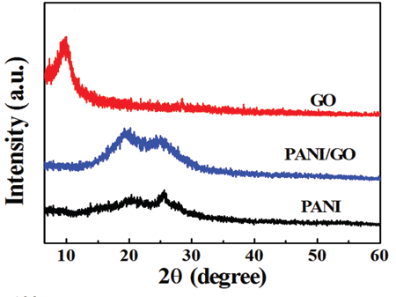
Figure S11. Pore size distributions of prepared membranes with bimodal porous
structure. Reproduced with permission from [254]. Copyright 2012 The Royal Society
of Chemistry.
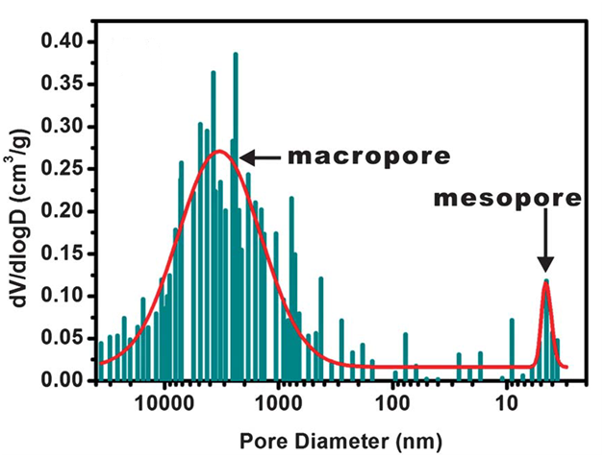
Figure S12. SEM images of CaCO₃ crystals in pepsin aqueous solution (a and b). Reprinted with permission from [255]. Copyright 2012 Elsevier.
