Supplementary Information
Table S1. Demographic and clinical characteristics of Group 2 subjects.
Variables | Normotensives  N = 117 | Hypertensives  N = 107
Age (years) | 49.0 ± 11.1 | 53.1 ± 10.2
Men (%) | 28 (23.9) | 61 (57.0)
Diabetes (%) | 3 (2.6) | 8 (7.5)
Body weight (kg) | 59.4 ± 9.1 | 67.9 ± 12.1
Height (cm) | 161.2 ± 7.0 | 164.4 ± 7.9
Serum sodium (mmol/dL) | 140.3 ± 2.2 | 140.5 ± 2.6
Serum potassium (mmol/dL) | 4.4 ± 0.5 | 4.3 ± 0.4
Serum creatinine (mg/dL) | 0.76 ± 0.15 | 0.84 ± 0.17
24-hour urine sodium (mmol/24-hour) | 147.9 ± 51.1 | 184.3 ± 73.9
Data are expressed as mean ± standard deviation, or numbers and percentages in parentheses, as appropriate.
Table S2. Calculated 24-hour urine sodium excretion obtained by six equations in normotensive subjects.
Equations | Mean ± SD | Mean difference | p *
Kawasaki’s equation (mmol/24-hour) | 181.5 ± 45.3 | -33.9 ± 39.7 | <0.001
Tanaka’s equation (mmol/24-hour) | 145.9 ± 29.8 | 2.0 ± 39.9 | 0.594
INTERSALT equation (mmol/24-hour) | 120.7 ± 23.7 | 27.1 ± 44.4 | <0.001
Linear equation (mmol/24-hour) | 145.7 ± 36.9 | 2.2 ± 37.7 | 0.523
Quadratic equation (mmol/24-hour) | 145.6 ± 36.7 | 2.3 ± 37.7 | 0.515
Cubic equation (mmol/24-hour) | 145.8 ± 36.6 | 2.1 ± 37.7 | 0.552
Mean difference was calculated by subtracting estimated from measured 24-hour urine sodium excretion.
* Estimated 24-hour urine sodium excretion by each equation was compared to measured 24-hour urine sodium excretion (mean ± SD, 147.9 ± 51.1 mmol/24-hour) by paired t-test.
Table S3. Calculated 24-hour urine sodium excretion obtained by six equations in hypertensive subjects.
Equations | Mean ± SD | Mean difference | p *
Kawasaki’s equation (mmol/24-hour) | 210.5 ± 68.9 | −26.2 ± 67.1 | <0.001
Tanaka’s equation (mmol/24-hour) | 160.9 ± 42.2 | 23.5 ± 64.0 | <0.001
INTERSALT equation (mmol/24-hour) | 143.7 ± 34.8 | 40.6 ± 61.5 | <0.001
Linear equation (mmol/24-hour) | 174.8 ± 69.1 | 9.5 ± 66.9 | 0.145
Quadratic equation (mmol/24-hour) | 175.9 ± 72.2 | 8.4 ± 68.5 | 0.205
Cubic equation (mmol/24-hour) | 184.7 ± 100.4 | −0.3 ± 88.9 | 0.969
Mean difference was calculated by subtracting estimated from measured 24-hour urine sodium excretion.
* Estimated 24-hour urine sodium excretion by each equation was compared to measured 24-hour urine sodium excretion (mean ± SD, 184.3 ± 73.9 mmol/24-hour) by paired t-test.

Figure S1. Relationship between measured and estimated 24-hour urine sodium obtained by six equations in normotensive subjects. (a) Kawasaki’s equation, (b) Tanaka’s equation, (c) INTERSALT equation, (d) linear equation, (e) quadratic equation, and (f) cubic equation.
a)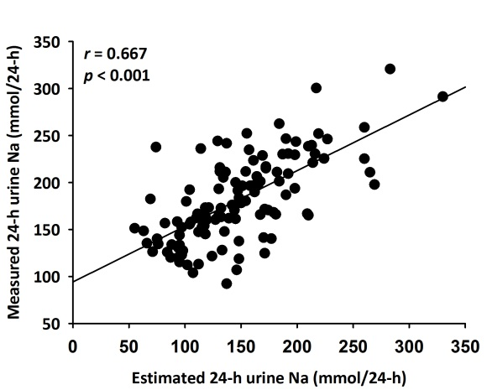 b)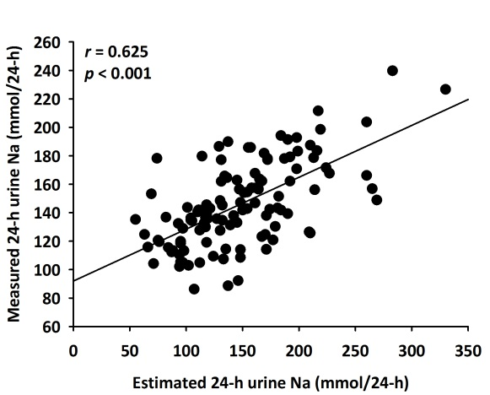
c)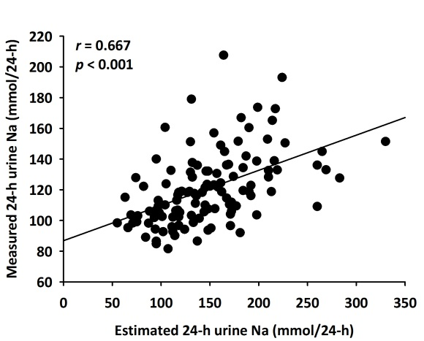 d)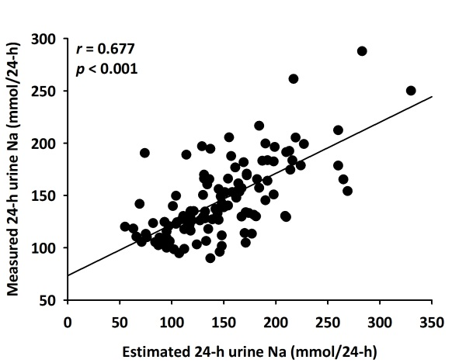
e)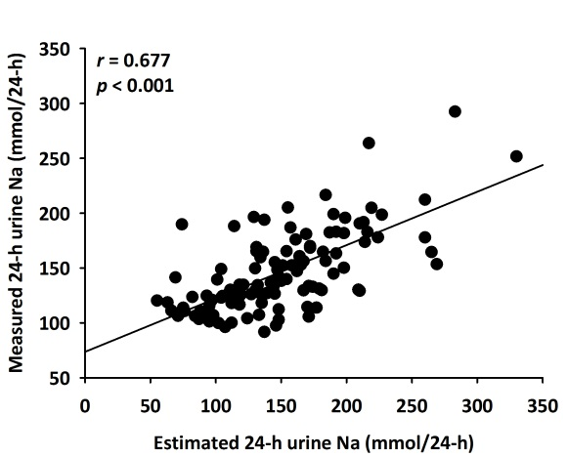 f)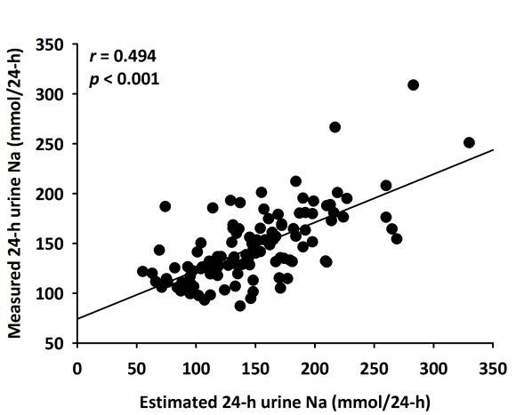

Figure S2. Bland-Altman analysis for agreement of the six equations in normotensive subjects. (a) Kawasaki’s equation, (b) Tanaka’s equation, (c) INTERSALT equation, (d) linear equation, (e) quadratic equation, (f) cubic equation.
a)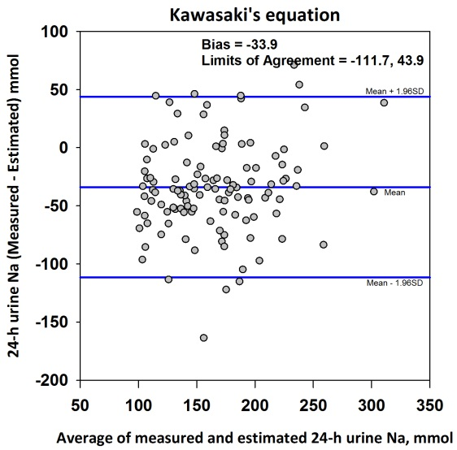 b)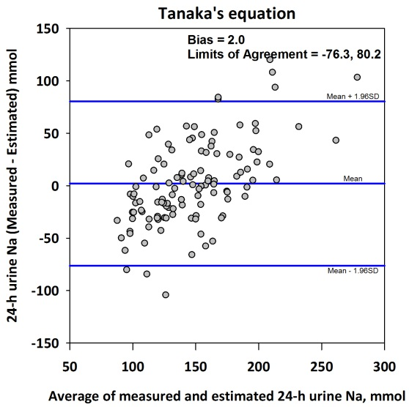
c)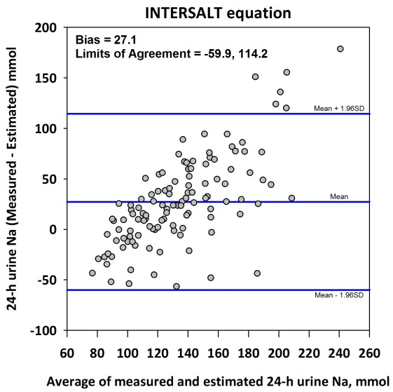 d)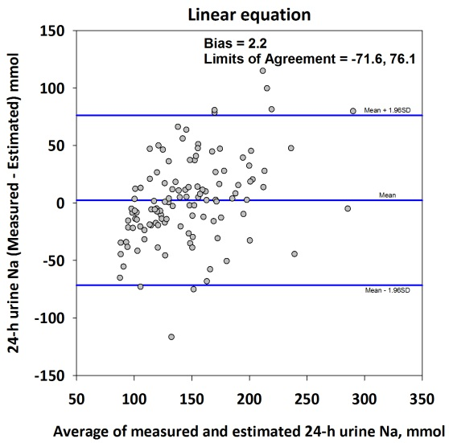
e)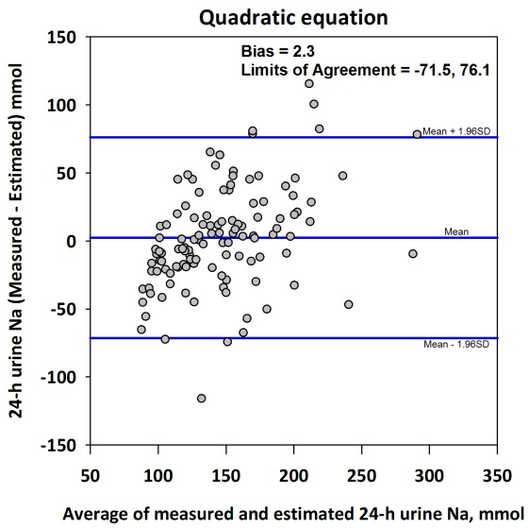 f)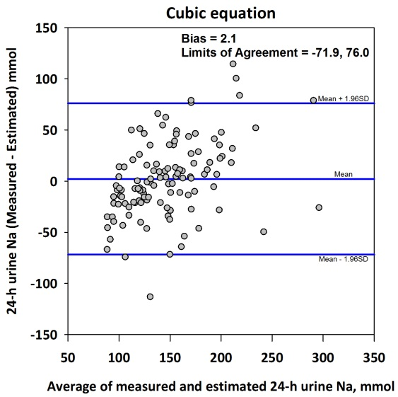

Figure S3. Relationship between the differences of measured and estimated 24-hour urine sodium against measured 24-hour urine sodium in normotensive subjects. (a) Kawasaki’s equation, (b) Tanaka’s equation, (c) INTERSALT equation, (d) linear equation, (e) quadratic equation, and (f) cubic equation.
a)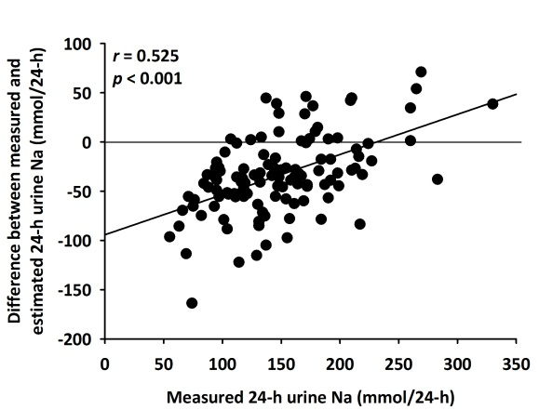 b)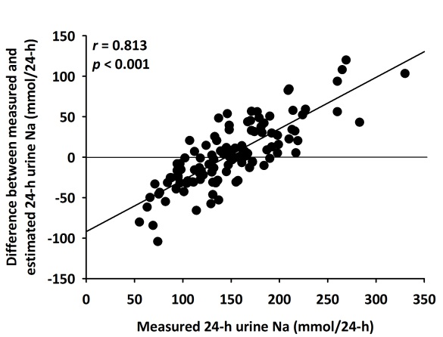
c)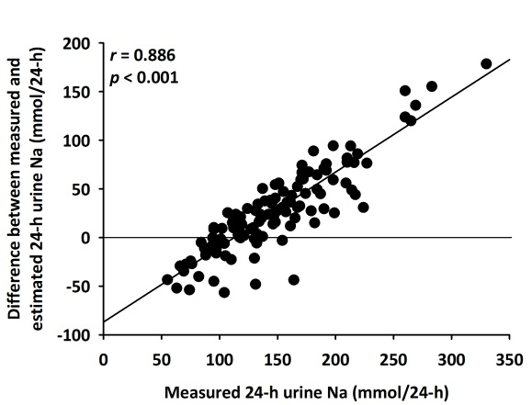 d)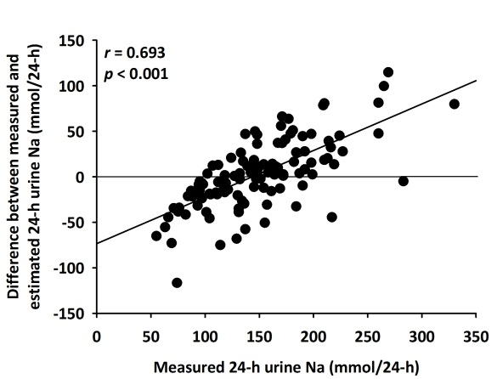
e)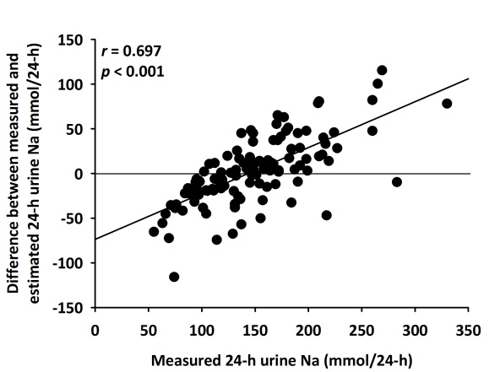 f)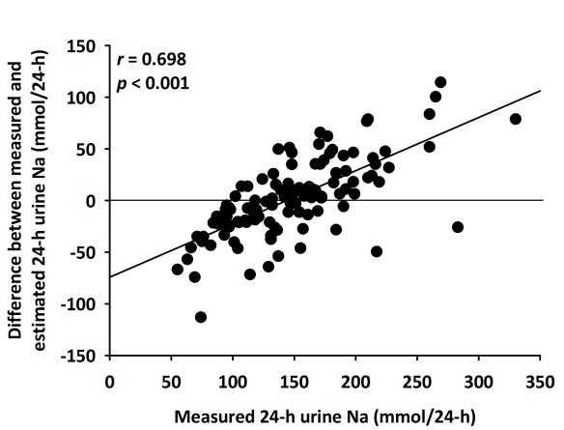

Figure S4. Relationship between measured and estimated 24-hour urine sodium obtained by six equations in hypertensive subjects. (a) Kawasaki’s equation, (b) Tanaka’s equation, (c) INTERSALT equation, (d) linear equation, (e) quadratic equation, and (f) cubic equation
a)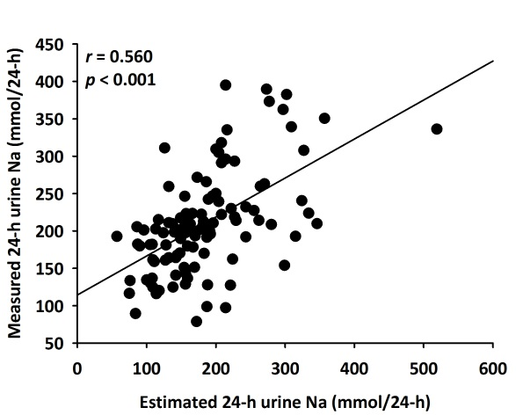 b)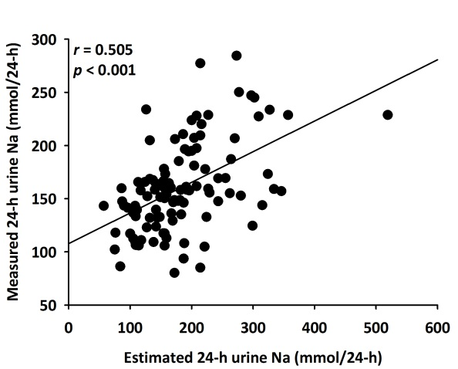
c)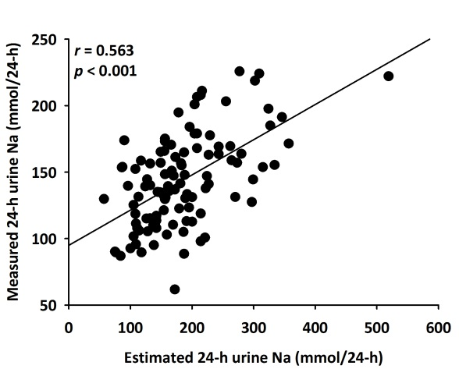 d)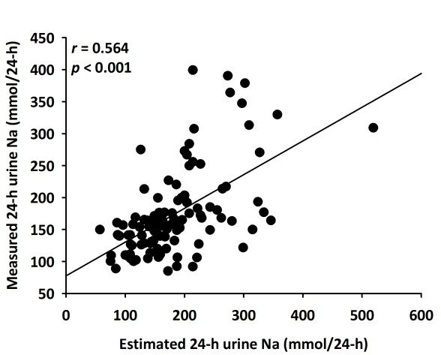
e)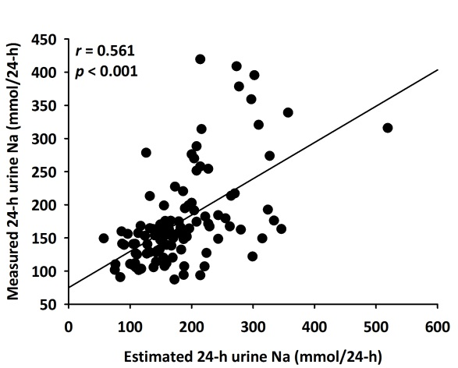 f)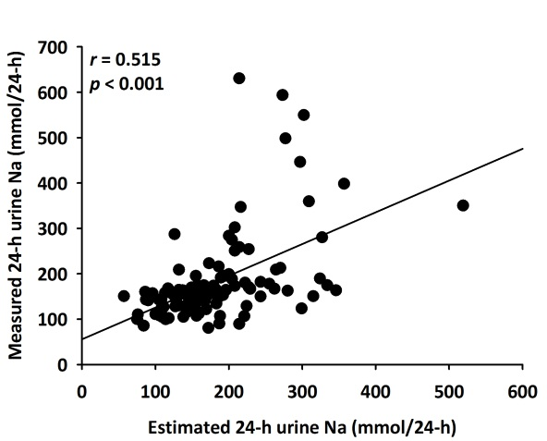

Figure S5. Bland-Altman analysis for agreement of the five equations in hypertensive subjects. (a) Kawasaki’s equation, (b) Tanaka’s equation, (c) INTERSALT equation, (d) linear equation, (e) quadratic equation, (f) cubic equation.
a)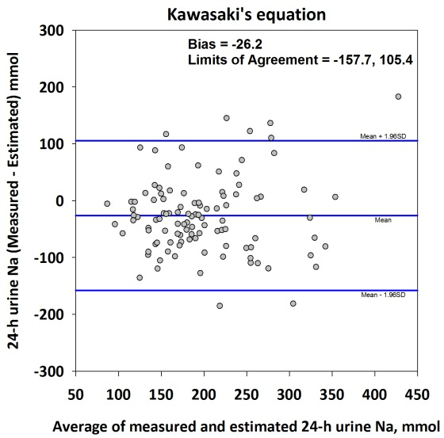 b)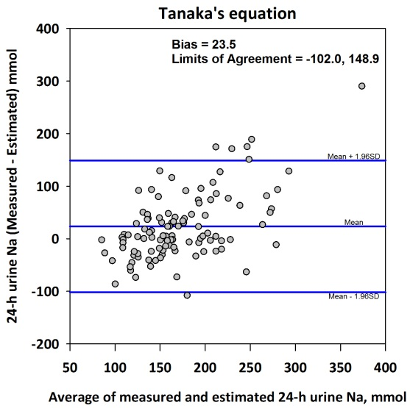
c)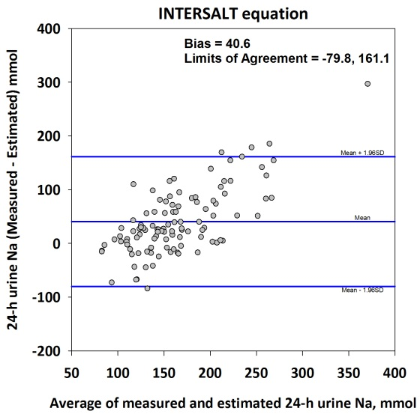 d)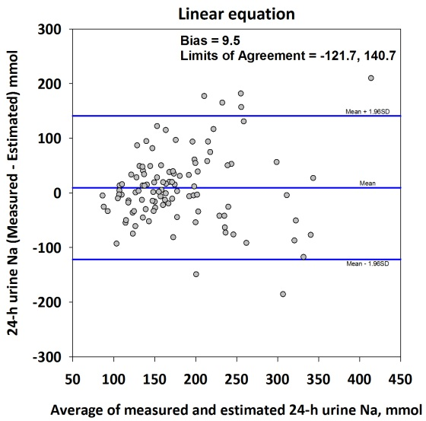
e)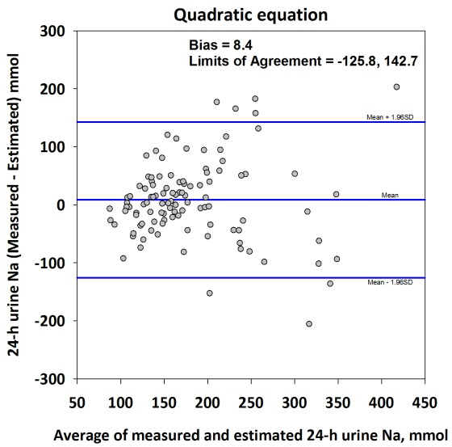 f)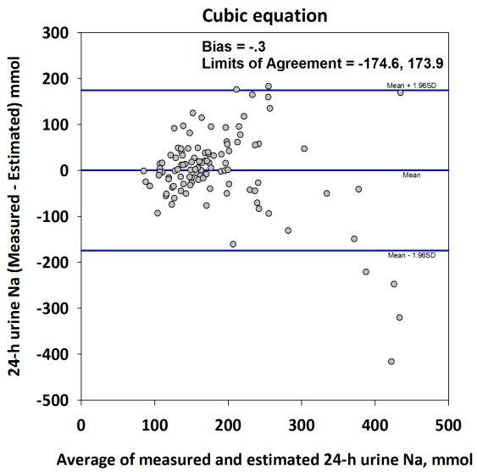

Figure S6. Relationship between the differences of measured and estimated 24-hour urine sodium against measured 24-hour urine sodium in hypertensive subjects. (a) Kawasaki’s equation, (b) Tanaka’s equation, (c) INTERSALT equation, (d) linear equation, (e) quadratic equation, and (f) cubic equation.
a)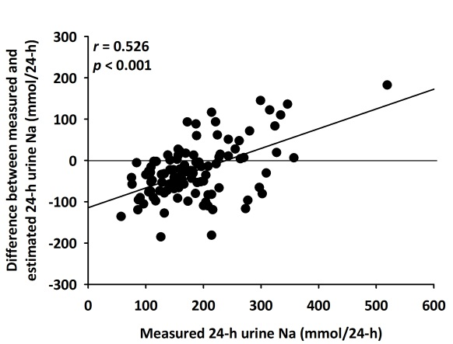 b)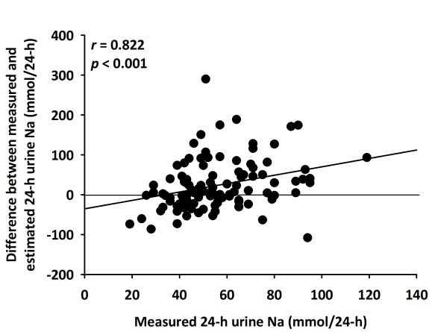
c)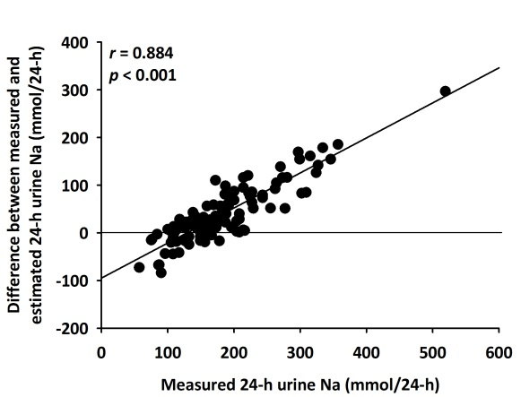 d)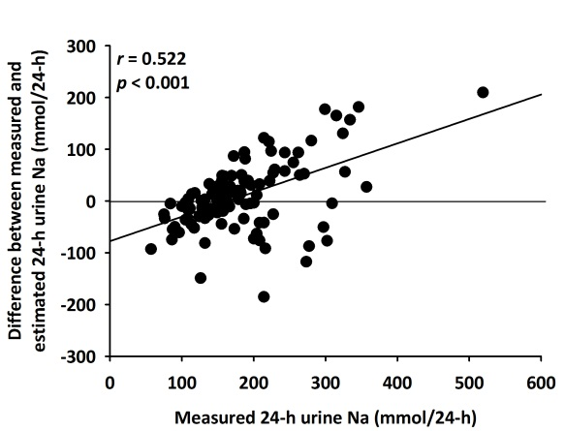
e)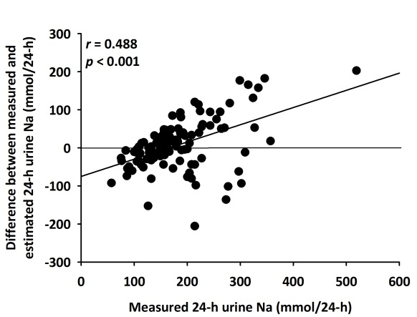 f)