Supplementary Materials

NMR Analysis

Lopinavir
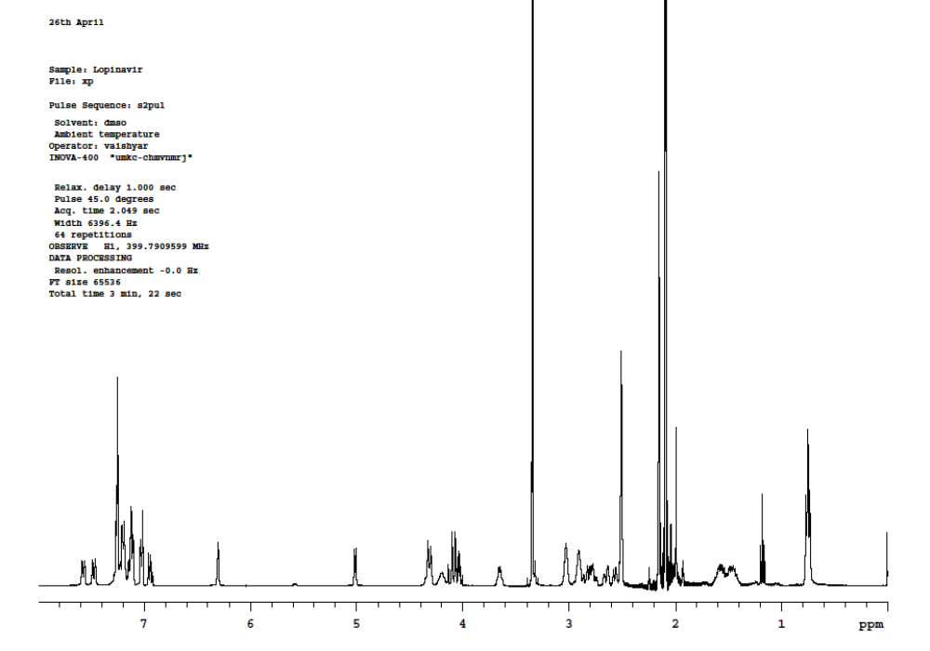

Isoleucine-LPV (Ile-LPV)
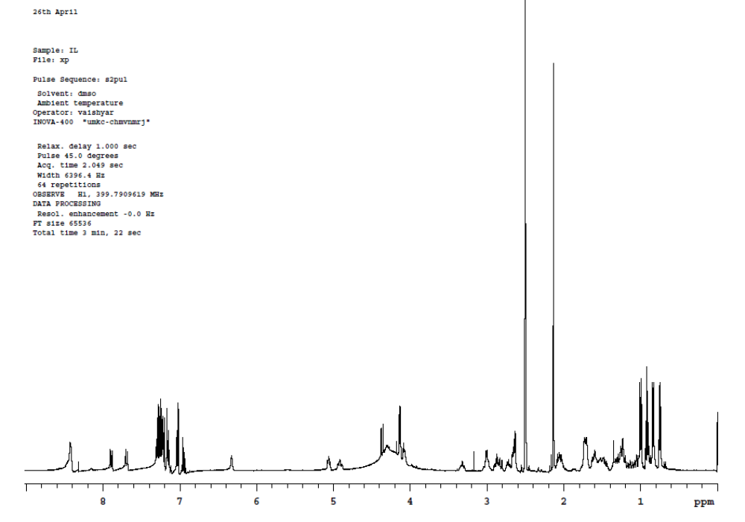

Methionine-LPV (Met-LPV)
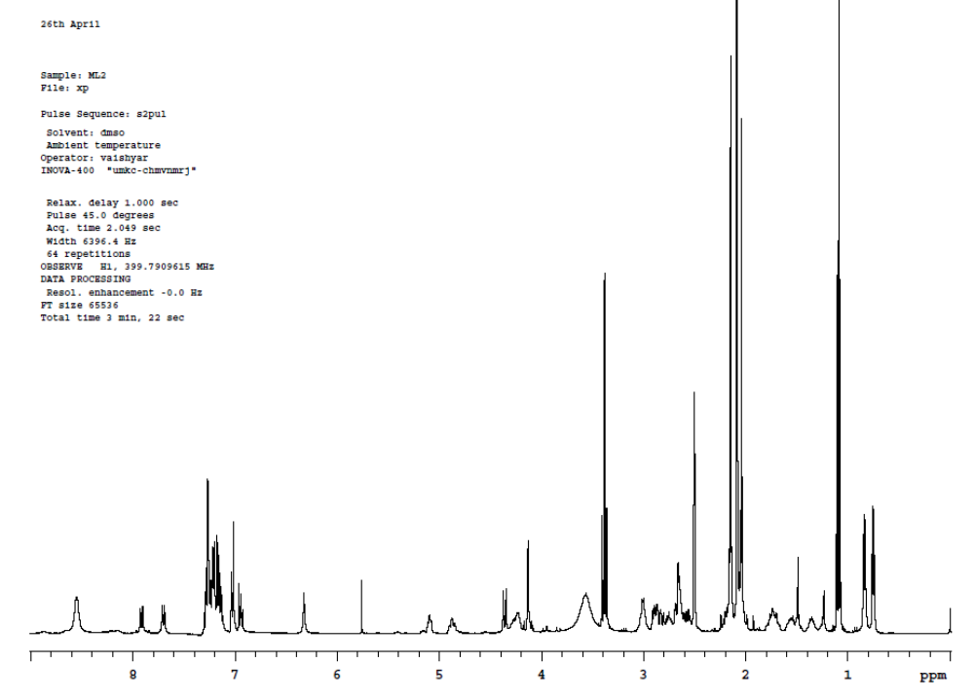

Tryptophan-LPV (Trp-LPV)
