OPEN ACCESS
Remote Sensing
ISSN 2072-4292
www.mdpi.com/journal/remotesensing
Supplementary Information
Allometric Scaling and Resource Limitations Model of Tree Heights: Part 1. Model Optimization and Testing over Continental USA. Remote Sens. 2013, 5, 284–306
Yuli Shi ^{1,2,†}, Sungho Choi ^{2,†,}*, Xiliang Ni ^{2,3}, Sangram Ganguly ⁴, Gong Zhang ⁵, Hieu V. Duong ⁶, Michael A. Lefsky ⁶, Marc Simard ⁷, Sassan S. Saatchi ⁷, Shihyan Lee ⁸, Wenge Ni-Meister ⁸, Shilong Piao ⁹, Chunxiang Cao ³, Ramakrishna R. Nemani ¹⁰ and Ranga B. Myneni ²
¹ School of Remote Sensing, Nanjing University of Information Science and Technology, Nanjing 210044, China; E-Mail: ylshi.nuist@gmail.com
² Department of Earth and Environment, Boston University, 675 Commonwealth Avenue, Boston, MA 02215, USA; E-Mail: ranga.myneni@gmail.com
³ State Key Laboratory of Remote Sensing Sciences, Institute of Remote Sensing Applications, Chinese Academy of Sciences, Beijing 100101, China; E-Mails: nixl@irsa.ac.cn (X.N.); cao413@irsa.ac.cn (C.C.)
⁴ Bay Area Environmental Research Institute (BAERI)/NASA Ames Research Center, Moffett Field, CA 94035, USA; E-Mail: sangramganguly@gmail.com
⁵ Department of Watershed Science, Utah State University, Logan, UT 84322, USA;
E-Mail: gongzhang07@gmail.com
⁶ Center for Ecological Analysis of Lidar, Natural Resource Ecology Laboratory, Colorado State University, Fort Collins, CO 80523, USA; E-Mails: dr.hieu.duong@gmail.com (H.D.); lefsky@cnr.colostate.edu (M.L.)
⁷ Jet Propulsion Laboratory, California Institute of Technology, 4800 Oak Grove Dr., Pasadena, CA 91109, USA;
E-Mails: marc.simard@jpl.nasa.gov (M.S.); saatchi@jpl.nasa.gov (S.S.)
⁸ Department of Geography, Hunter College of CUNY, New York, NY 10065, USA;
E-Mails: shihyanlee@yahoo.com (S.L.); Wenge.Ni-Meister@hunter.cuny.edu (W.N.)
⁹ College of Urban and Environmental Sciences and Sino-French Institute for Earth System Science, Peking University, Beijing 100871, China; E-Mail: slpiao@pku.edu.cn
¹⁰ Biospheric Science Branch, NASA Ames Research Center, Moffett Field, CA 94035, USA;
E-Mail: rama.nemani@nasa.gov
† These authors contributed equally to this work.
* Author to whom correspondence should be addressed; E-Mail: schoi@bu.edu;
Tel.: +1-617-353-8846; Fax: +1-617-353-8846.

List of Abbreviations
ASRL Allometric Scaling and Resource Limitations
DEM Digital Elevation Model
GLA14 GLAS Level-2 Land Surface Altimetry
GLAS Geoscience Laser Altimeter System
ICESat Ice, Cloud, and land Elevation Satellite
IDW Inverse Distance Weighting
LAI Leaf Area Index
LVIS Laser Vegetation Imaging Sensor
MODIS Moderate Resolution Imaging Spectroradiometer
NARR North American Regional Reanalysis
NDVI Normalized Vegetation Difference Vegetation Index
NED National Elevation Dataset
NLCD National Land Cover Database
RMSE Root Mean Square Error
TSF Temporal Spatial Filter
VCF Vegetation Continuous Fields
WMO World Meteorology Organization

S1. Data

S1.1. Annual Average Relative Humidity
Annual average temperature and annual average vapor pressure from DAYMET data were converted to annual average relative humidity (Φ) using a formula provided by World Meteorological Organization (WMO) [1] (Equation (S1)).
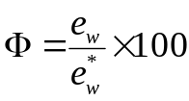  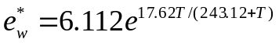 | (S1)
Here e_{w} is vapor pressure (hPa), e_{w}* is statured vapor pressure (hPa) and T is air temperature (°C).

S1.2. Growing Season Average Leaf Area Index
An input to the ASRL model is the growing season average Leaf Area Index (LAI). This was derived from a refined version of the standard Moderate Resolution Imaging Spectroradiometer (MODIS) LAI product [2]. As documented in Yuan et al. [3], the standard MODIS LAI product was post-processed using a two-step integrated approach: (a) a modified version of a temporal spatial filter (TSF) was applied [4,5] that replaced lower quality data to an equivalent best case scenario (gap filled data) based on quality control (QC) layers and (b) the final post-processing of the LAI product was performed using the TIMESAT Savitzky-Golay (SG) filter [6]. The 8-day composites of the post-processed MODIS LAI product from 2003 to 2008 (June to September; approximate growing season) were used to evaluate growing season average LAI data based on Equation (S2):
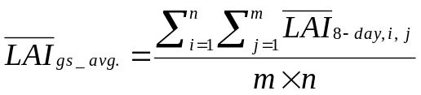 | (S2)
Here $\overline{LAI}$_{gs_avg.} is the approximate growing season average LAI (June to September months from years 2003 to 2006), $\overline{LAI}$_{8-day, i, j} is the 8-day LAI product for i^{th} week (m = 16) of j^{th} year (n = 4).
S2. Figures S1–S5
Figure S1. Distribution of GLAS heights over the continental USA. We applied a Gaussian decomposition approach of Lee et al. [7] using the signal begin range increment (SigBegOff) and the last peak of Gaussians (gpCntRntOff 1). The potential bias due to topographic conditions has been rectified [7]. This GLAS height metric is well correlated to field-measured and airborne lidar-derived tree heights [8]. Each raster (size 1 km) is not visible at a continental scale. So, we implemented point symbols corresponding to each pixel for better presenting of GLAS-derived tree heights in this figure.
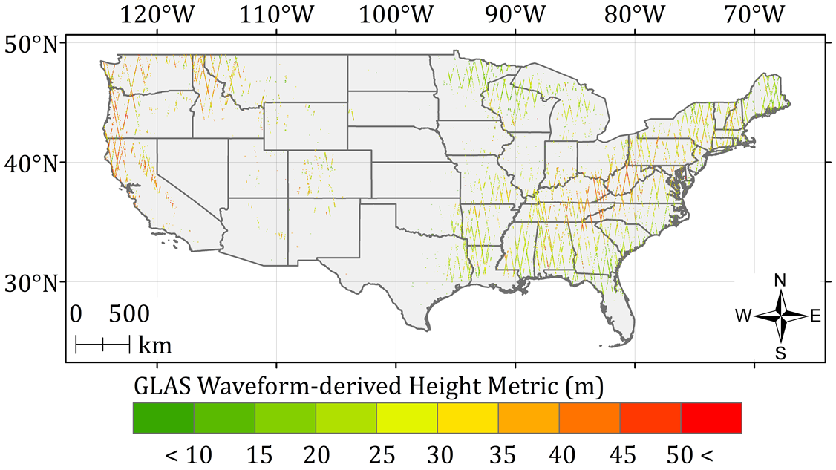

Figure S2. Distribution of climatic zones over the empirical orthogonal panel of annual total precipitation and annual average temperature Climatic zones were defined based on three forest types (deciduous, evergreen and mixed forests) and fixed intervals of precipitation (30 mm) and temperature (2 °C) over the continental USA. The study area was thus confined to 841 climatic zones.
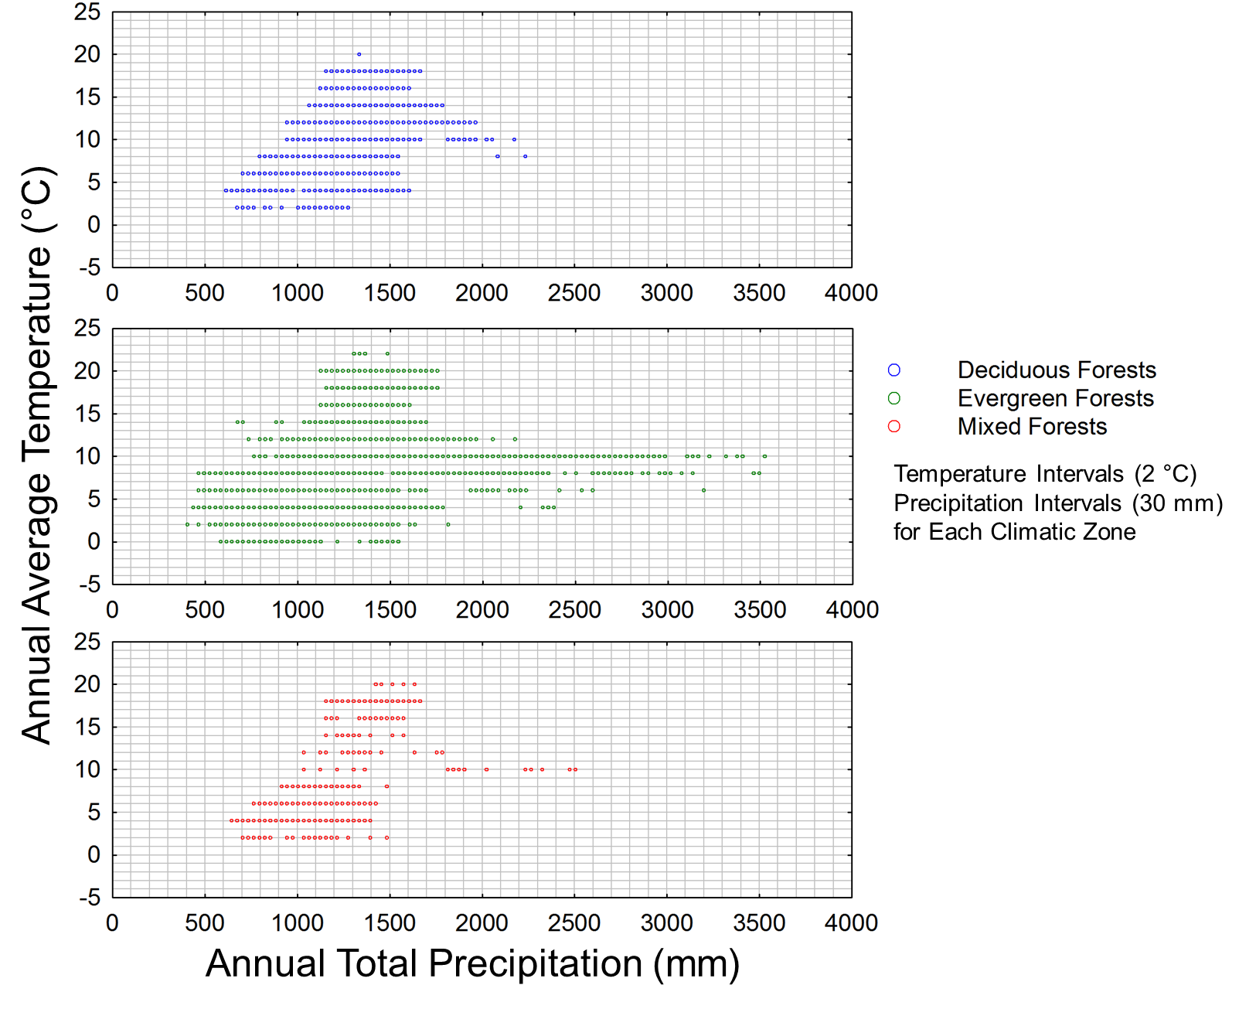

Figure S3. Spatial distribution of ASRL model prediction errors at pixel level. (a) Without optimization (H_{potential} _{ASRL} − H_{GLAS}). (b) After optimization (H_{opt} _{ASRL} − H_{GLAS}). See Figure S4 for corresponding histograms.
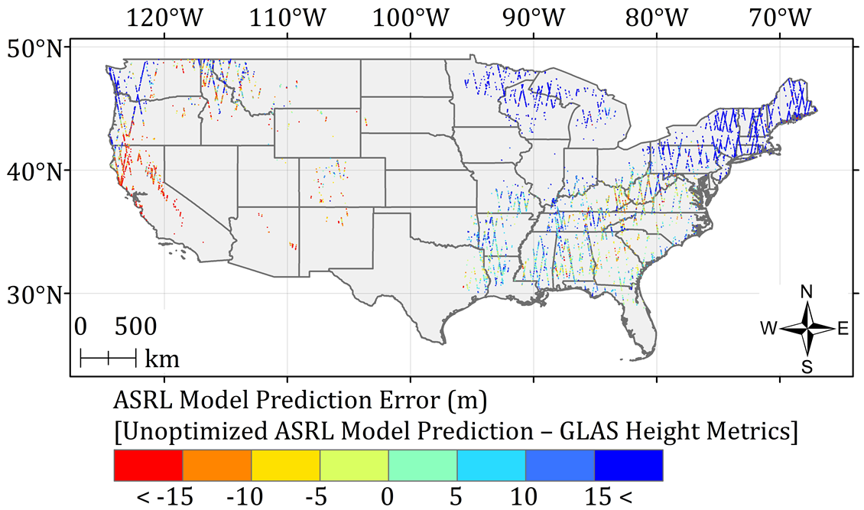
(a)
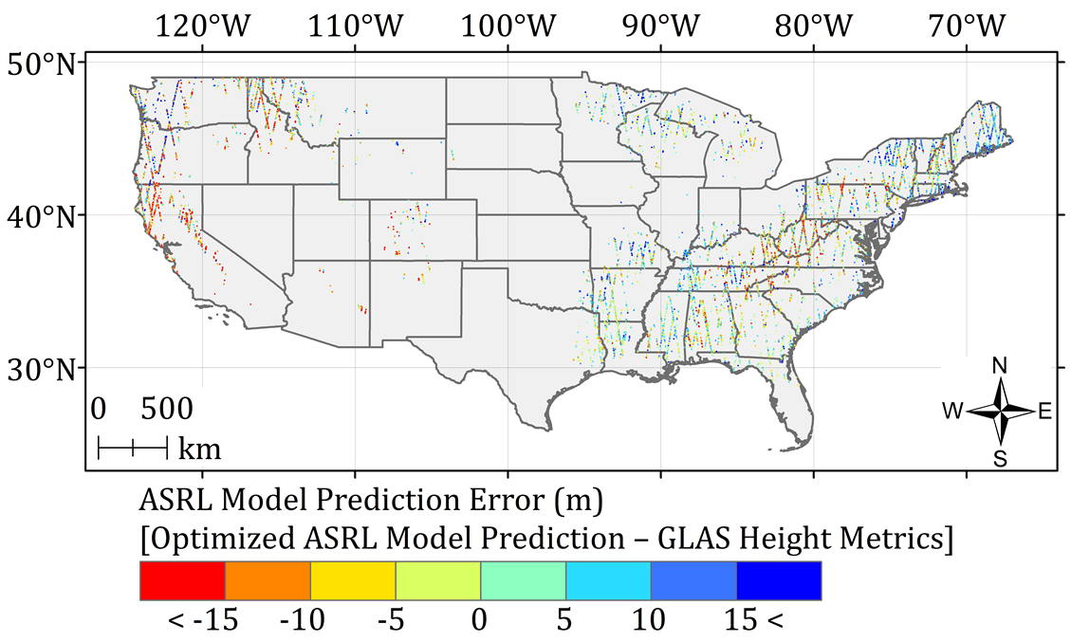
(b)

Figure S4. Histograms of ASRL model prediction errors at pixel level. (a) Without optimization (H_{potential} _{ASRL} – H_{GLAS}). (b) After optimization (H_{opt} _{ASRL} – H_{GLAS}).
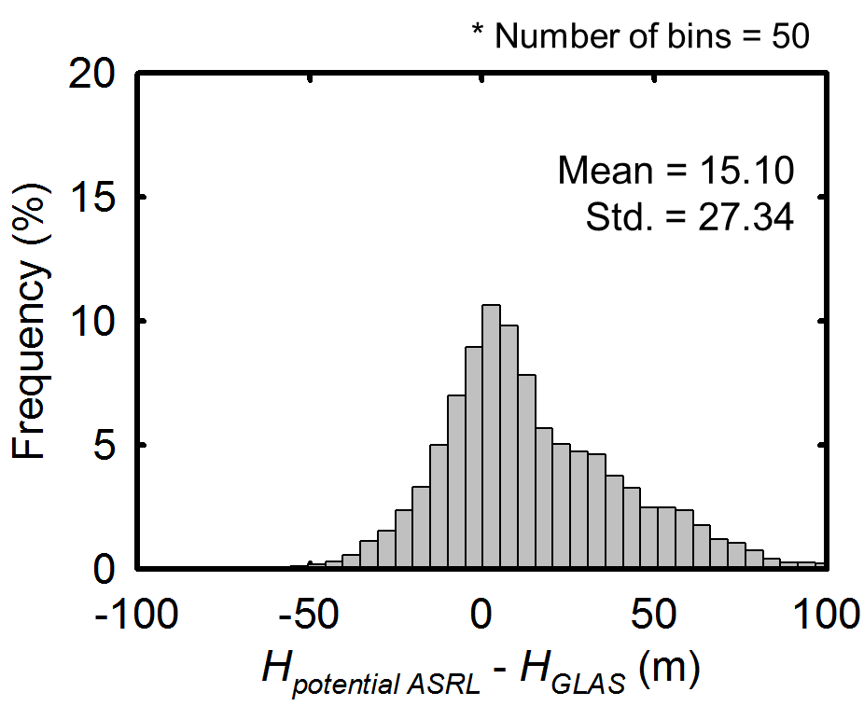 | 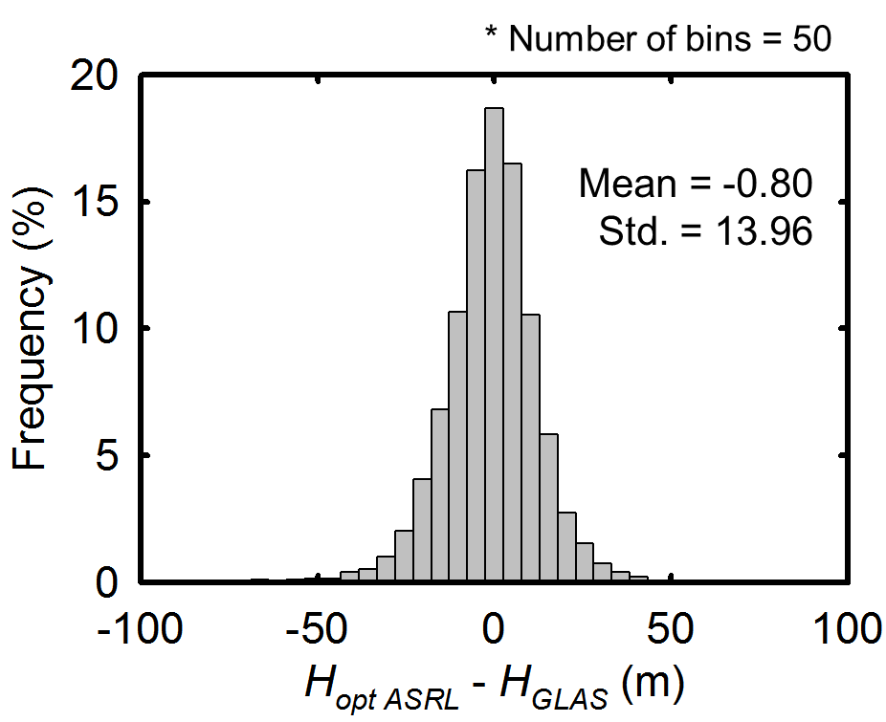
(a) | (b)
Figure S5. Number of valid GLAS data in each of the climatic zones considered in this study. Valid GLAS data density is relatively lower in the Northeastern Appalachian and Pacific Northwestern forest corridors.
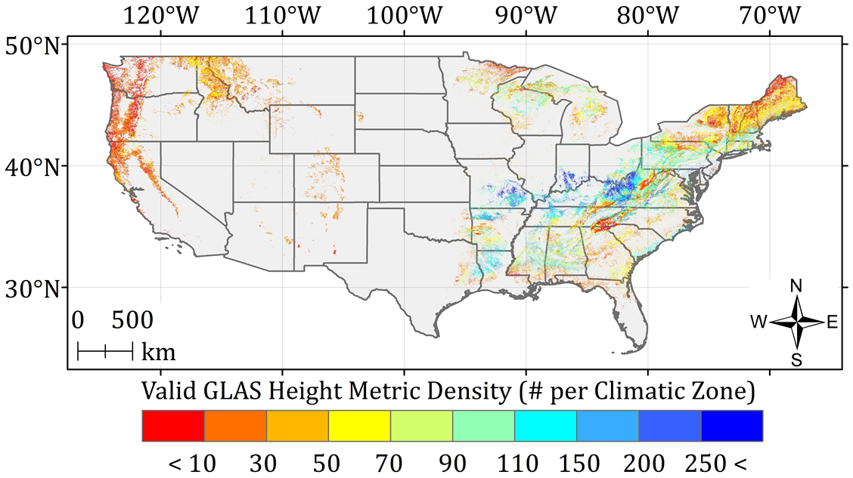

References
1. World Meteorological Organization (WMO). Guide to Meteorological Instruments and Methods of Observation, Appendix 4B, WMO-No. 8 (CIMO Guide); WMO: Geneva, Switzerland, 2008.
2. Land-Atmosphere Interaction Research Group at Beijing Normal University (BNU). LAI Data Sets for Land Surface and Climate Modeling. Available online: http://globalchange.bnu.edu.cn/
research/lai/ (accessed on 12 July 2012).
3. Yuan, H.; Dai, Y.J.; Xiao, Z.Q.; Ji, D.Y.; Wei, S.G. Reprocessing the MODIS Leaf Area Index products for land surface and climate modelling. Remote Sens. Environ. 2011, 115, 1171–1187.
4. Fang, H.L.; Liang, S.L.; Kim, H.Y.; Townshend, J.R.; Schaaf, C.L.; Strahler, A.H.; Dickinson, R.E. Developing a spatially continuous 1 km surface albedo data set over North America from Terra MODIS products. J. Geophys. Res.-Atmos. 2007, 112, doi: 10.1029/2006JD008377.
5. Fang, H.L.; Liang, S.L.; Townshend, J.R.; Dickinson, R.E. Spatially and temporally continuous LAI data sets based on an integrated filtering method: Examples from North America. Remote Sens. Environ. 2008, 112, 75–93.
6. Jonsson, P.; Eklundh, L. TIMESAT—A program for analyzing time-series of satellite sensor data. Comput. Geosci-UK. 2004, 30, 833–845.
7. Lee, S.; Ni-Meister, W.; Yang, W.Z.; Chen, Q. Physically based vertical vegetation structure retrieval from ICESat data: Validation using LVIS in White Mountain National Forest, New Hampshire, USA. Remote Sens. Environ. 2011, 115, 2776–2785.
8. Choi, S.; Ni, S.; Shi, Y.; Ganguly, S.; Zhang, G.; Duong, H.V.; Lefsky, M.A.; Simard, M.; Saatchi, S.S.; Lee, S.; et al. Allometric scaling and resource limitations model of tree heights: Part 2. Site based testing of the model. Remote Sens. 2013, 5, 202–223.
© 2013 by the authors; licensee MDPI, Basel, Switzerland. This article is an open access article distributed under the terms and conditions of the Creative Commons Attribution license (http://creativecommons.org/licenses/by/3.0/).

