OPEN ACCESS
Remote Sensing
ISSN 2072-4292
www.mdpi.com/journal/remotesensing
Supplementary Information
Evaluating and Quantifying the Climate-Driven Interannual Variability in Global Inventory Modeling and Mapping Studies (GIMMS) Normalized Difference Vegetation Index (NDVI3g) at Global Scales. Remote Sens. 2013, 5, 3918-3950
Fan-Wei Zeng ^{1,}*, G. James Collatz ², Jorge E. Pinzon ¹ and Alvaro Ivanoff ³
¹ SSAI, Biospheric Sciences Laboratory, NASA Goddard Space Flight Center, Code 618, Greenbelt, MD 20771, USA; E-Mail: jorge.e.pinzon@nasa.gov
² Biospheric Sciences Laboratory, NASA Goddard Space Flight Center, Code 618, Greenbelt,
MD 20771, USA; E-Mail: george.j.collatz@nasa.gov
³ ADNET, Cryospheric Sciences Laboratory, NASA Goddard Space Flight Center, Code 615, Greenbelt, MD 20771, USA; E-Mail: alvaro.ivanoff@nasa.gov
* Author to whom correspondence should be addressed; E-Mail: fanwei.zeng@nasa.gov;
Tel.: +1-301-614-6624; Fax: +1-301-614-6695.

The figures in this supplementary support the main text.

Figure S1. Spearman’s rank correlation coefficients (p* < 0.05) of GIMMS NDVI and GPCP precipitation anomalies at lead 1 (a) and of GIMMS NDVI and GISS temperature anomalies at lead 0 (b), compared to Pearson's correlation coefficients (p* < 0.05) for precipitation at lead 1 (c) and for temperature at lead 0 (d) for all months (N = 348 − lead). All the correlations have been corrected for temporal autocorrelation (Spatial resolution for NDVI–precipitation: 1°; for NDVI–temperature: 0.5°).

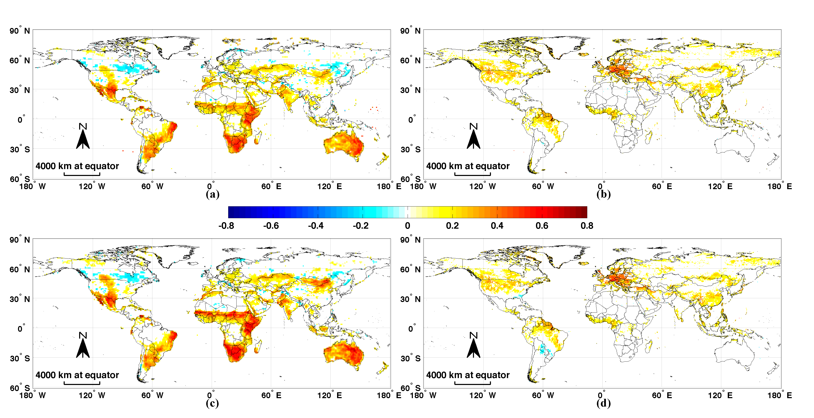

Figure S2. Global maps of significant (p < 0.05, r > 0.31) positive correlation coefficients for (a) GIMMS NDVI–MODIS Aqua NDVI anomalies (0.25°, monthly, 2003–2010), and (b) MODIS Aqua NDVI–MODIS Terra NDVI anomalies (0.25°, monthly,
2003–2010) for all months (N = 96).
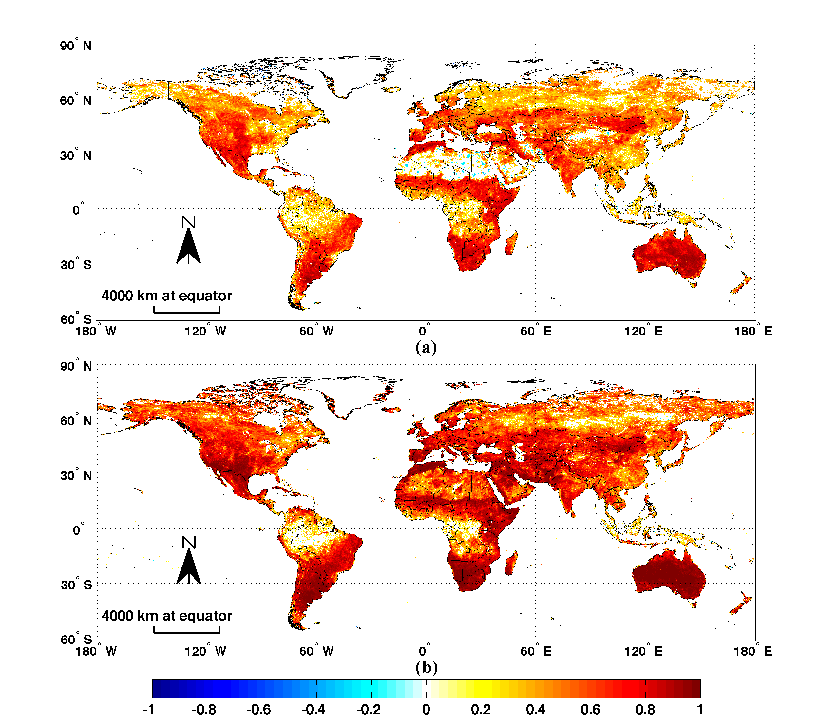

Figure S3. Global maps of correlation coefficients (p* < 0.05) between all monthly GIMMS NDVI and cumulative GPCP precipitation anomalies for durations varying from 1 to 10 months for 1982–2010 (a-j, N = 348 – duration + 1), and percentage of land grid cells that have significant (p* < 0.05) positive correlation coefficients as a function of duration (k). Note that 1-month duration is equivalent to 0-month lead. All the correlation coefficients have been corrected for temporal autocorrelation (Spatial resolution: 1°).

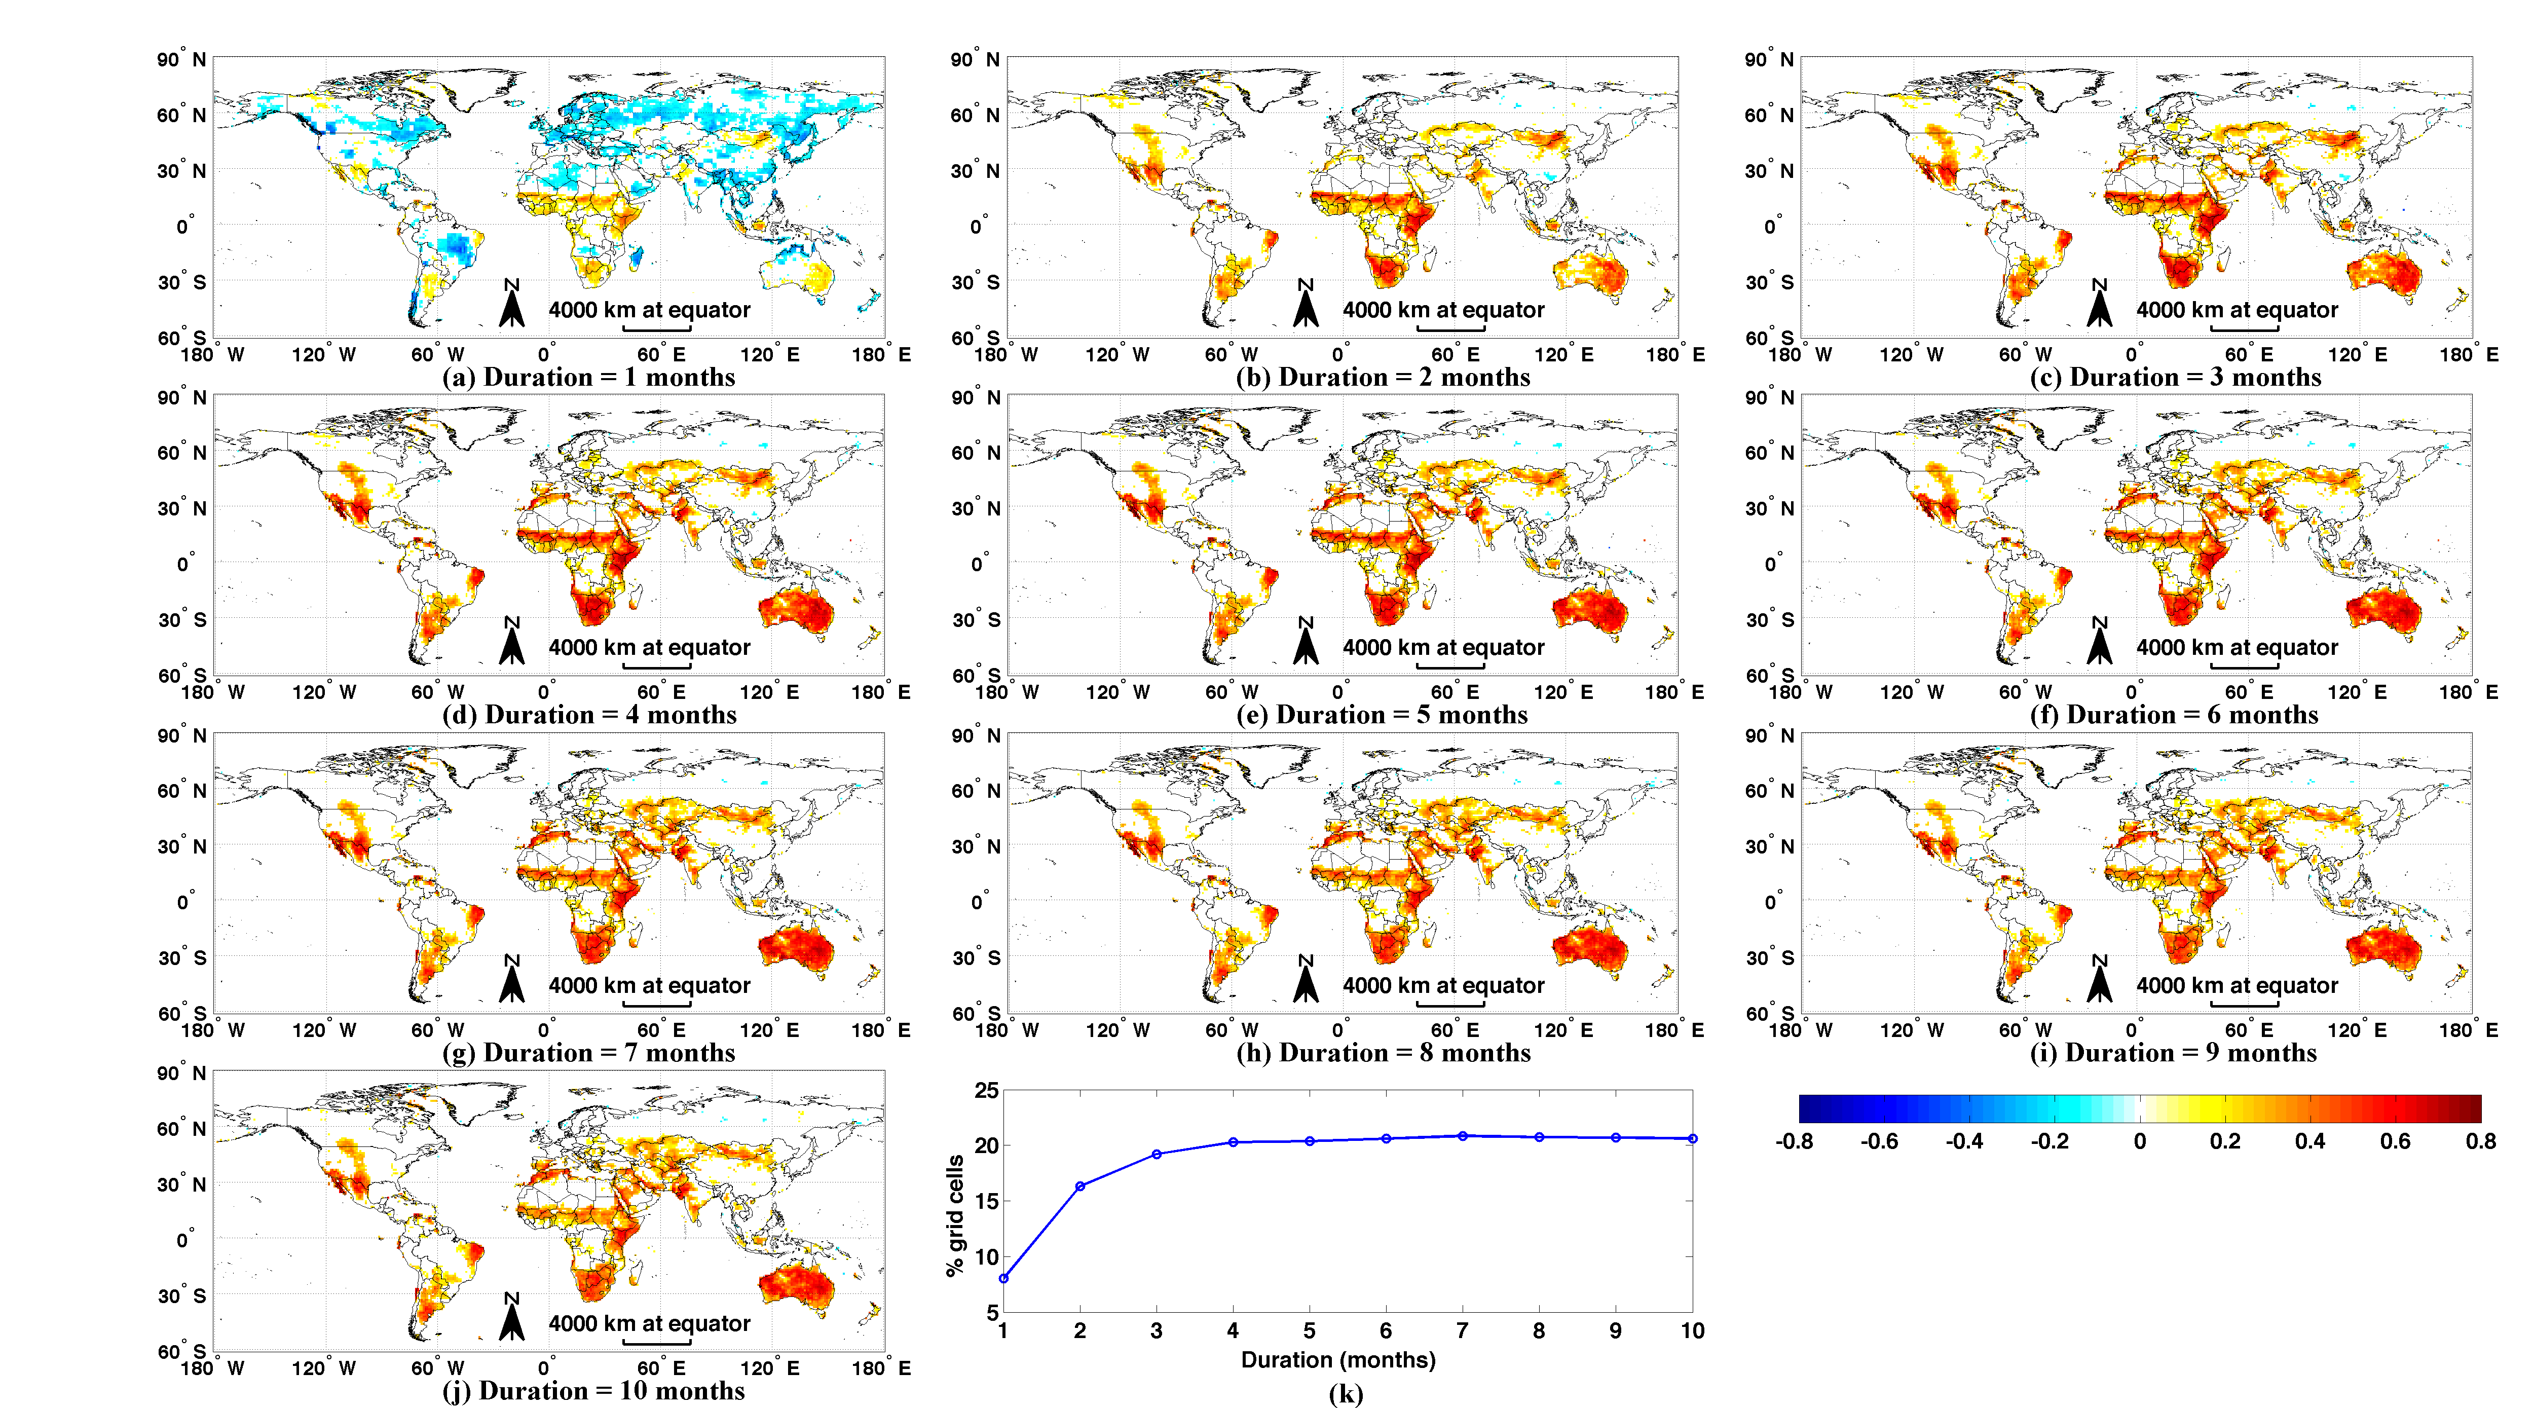

Figure S4. Monthly maps of significant correlation coefficients (p < 0.05) between GIMMS NDVI and GPCP precipitation for lead times ranging from 0 to 7 months (N = 29) (Spatial resolution: 1°).

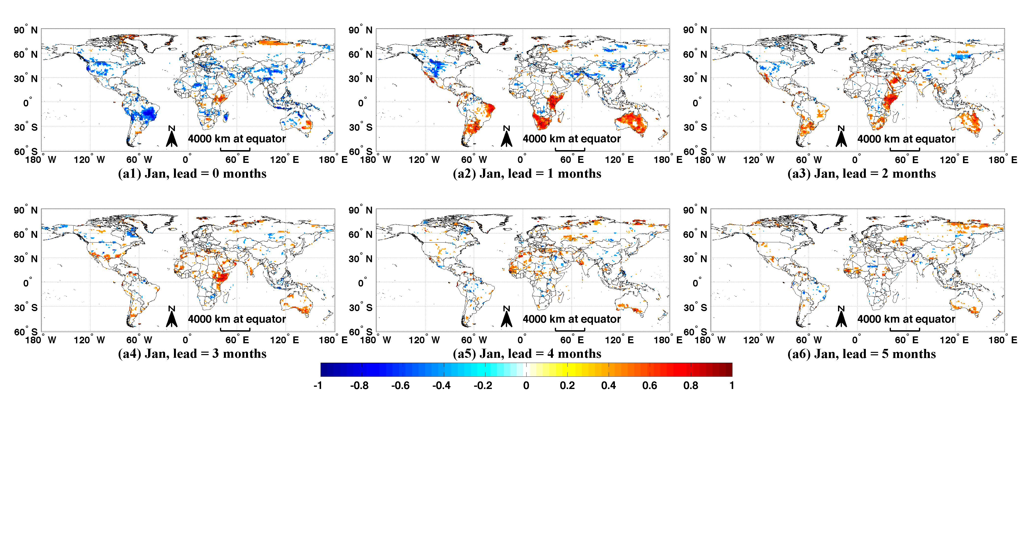

Figure S4. Cont.

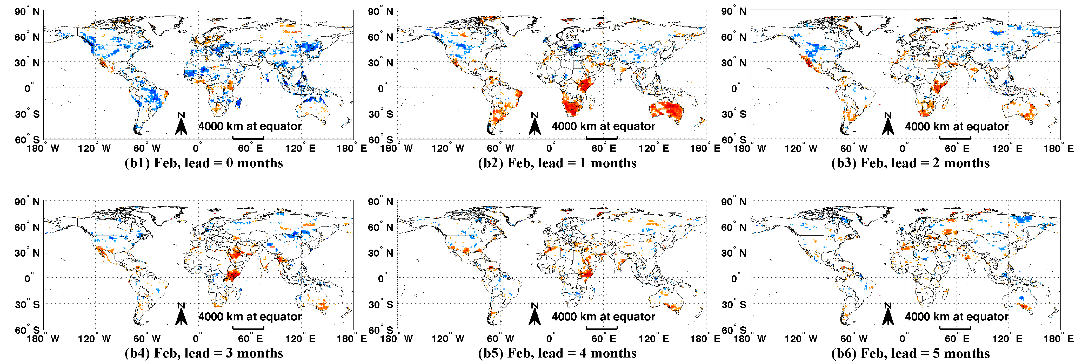

Figure S4. Cont.
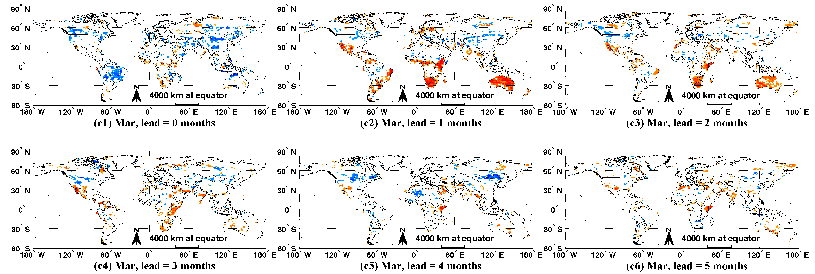

Figure S4. Cont.
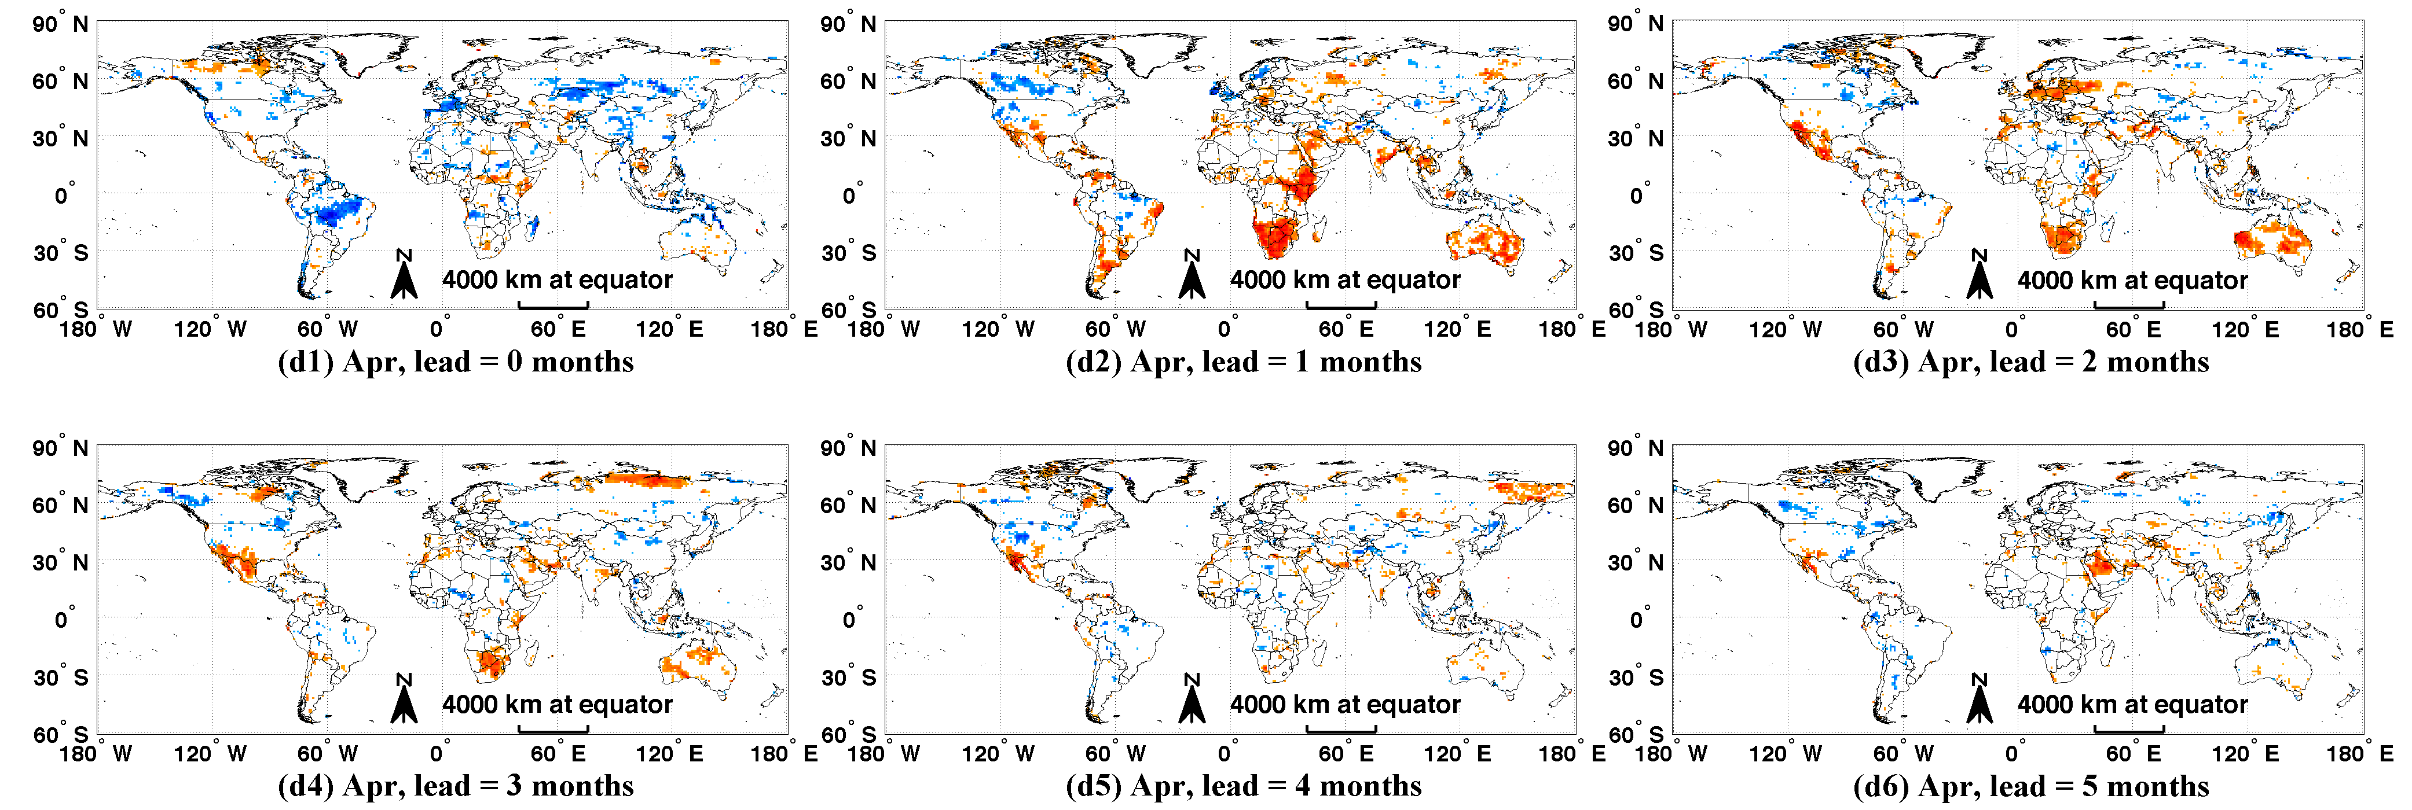

Figure S4. Cont.
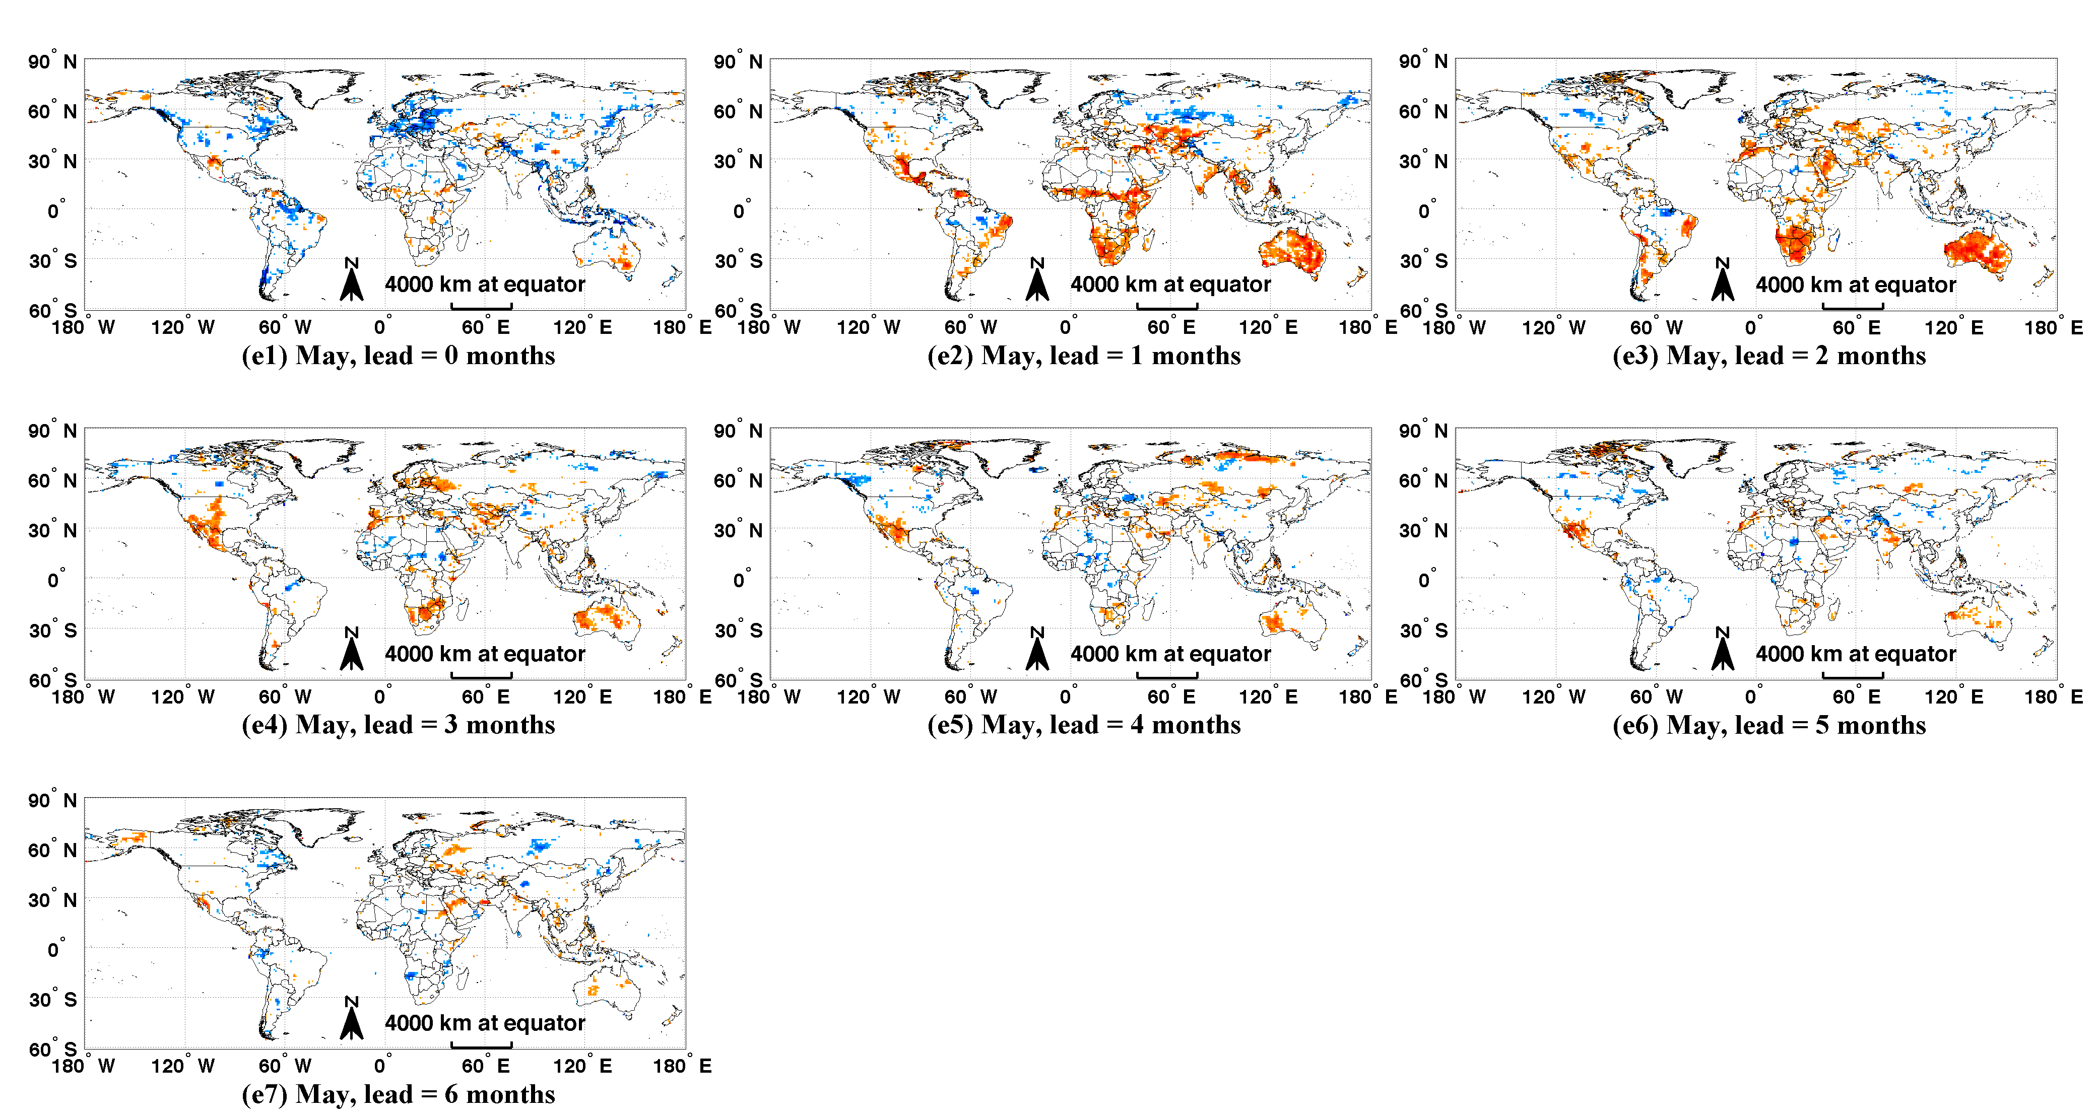

Figure S4. Cont.

Figure S4. Cont.
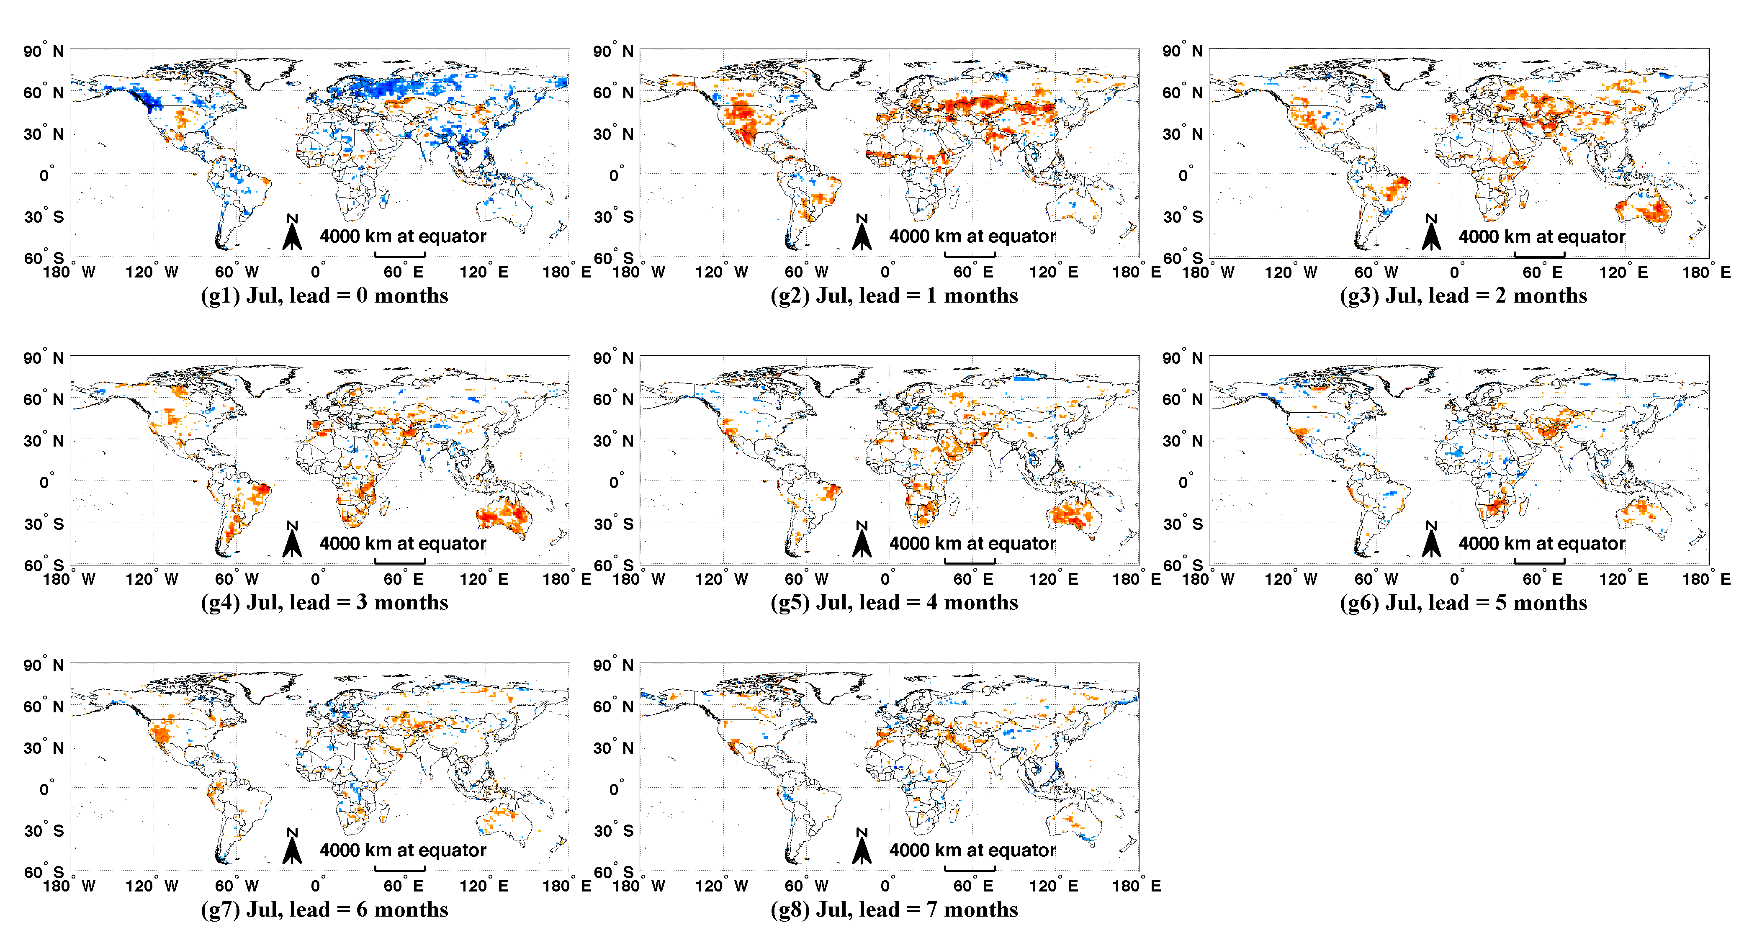

Figure S4. Cont.
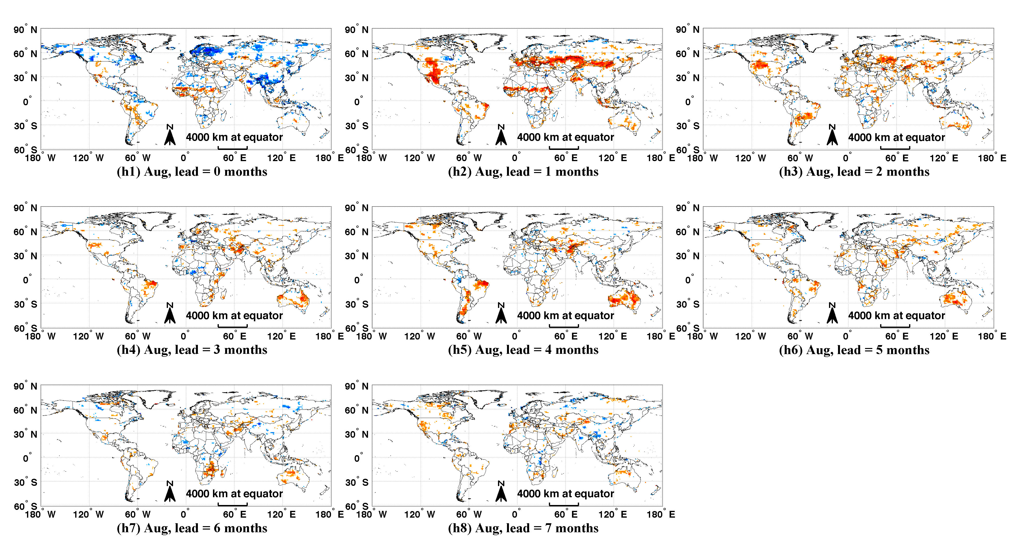

Figure S4. Cont.
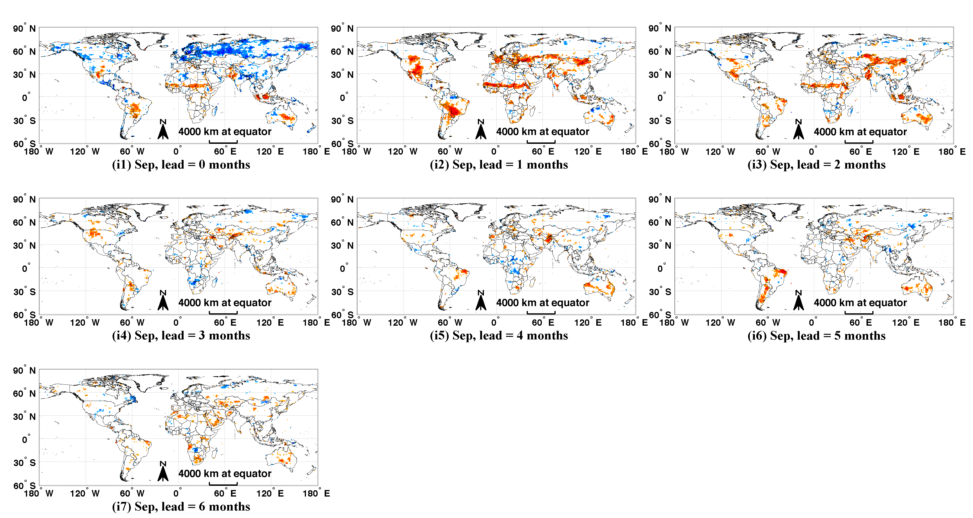

Figure S4. Cont.
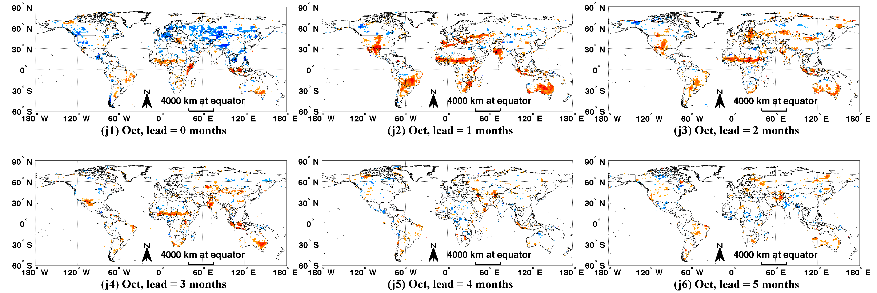

Figure S4. Cont.
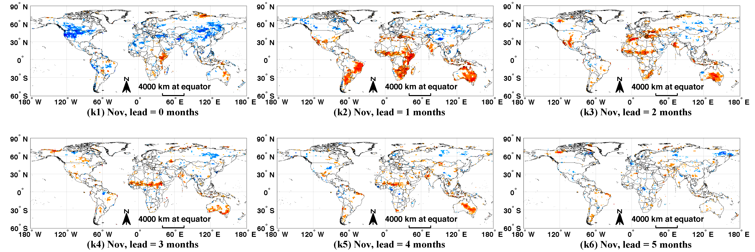

Figure S4. Cont.
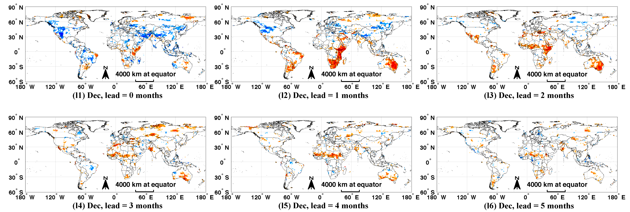

Figure S5. Monthly maps of (a) GIMMS NDVI variance (1982–2010), (b) the fraction of NDVI variance explained by climate (same as Figure 9, calculated from Equation (5) in Section 2.2.3), (c) the fraction of NDVI variance induced by current monthly precipitation, snow, aerosols and clouds (all negatively correlated with NDVI), and (d) the fraction of NDVI variance not explained by either climate or the interfering elements in (c). For (d), white color represents no significant correlation between NDVI and any of the climatic variables or interfering elements and the fraction of unexplained variance is set to be 1 (Spatial resolution: 0.5°).
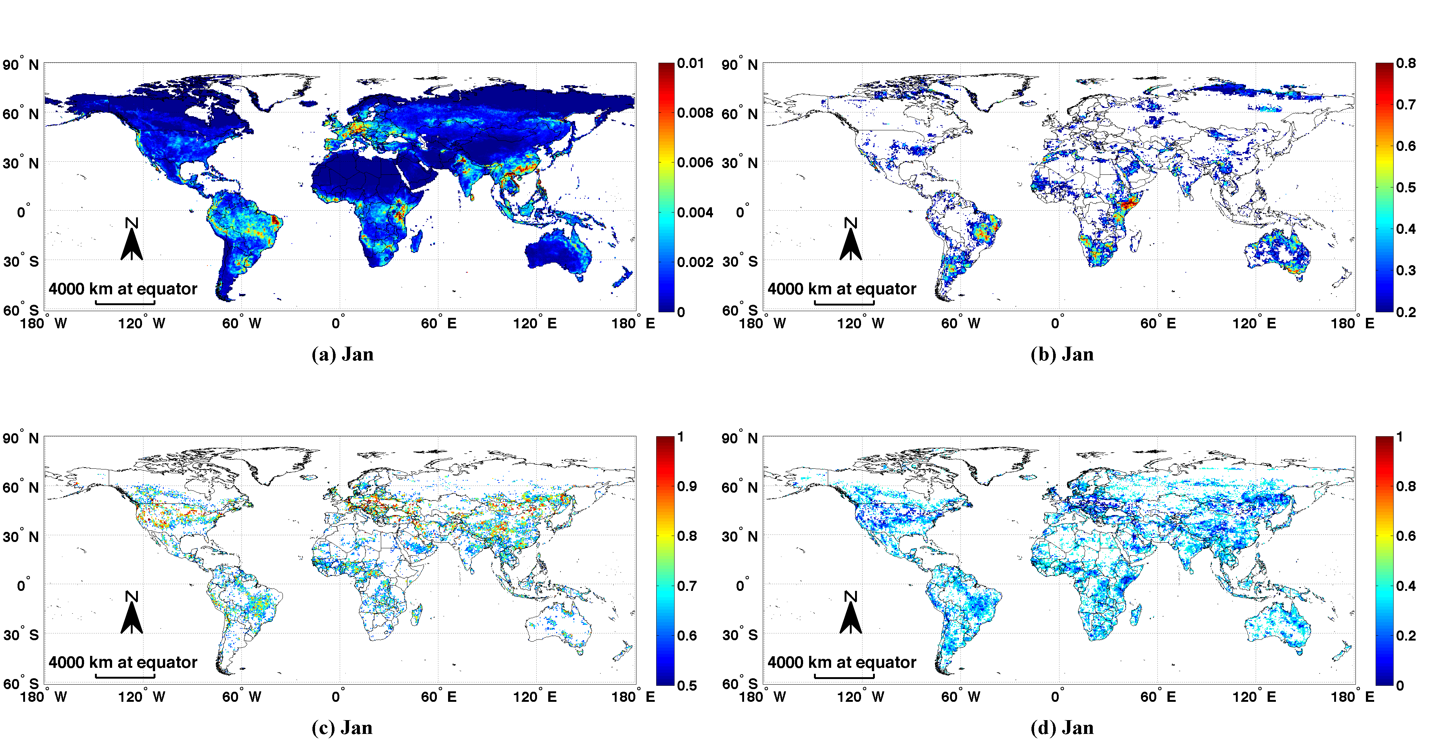

Figure S5. Cont.
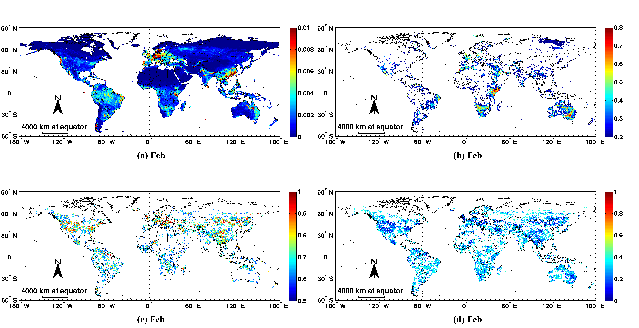

Figure S5. Cont.
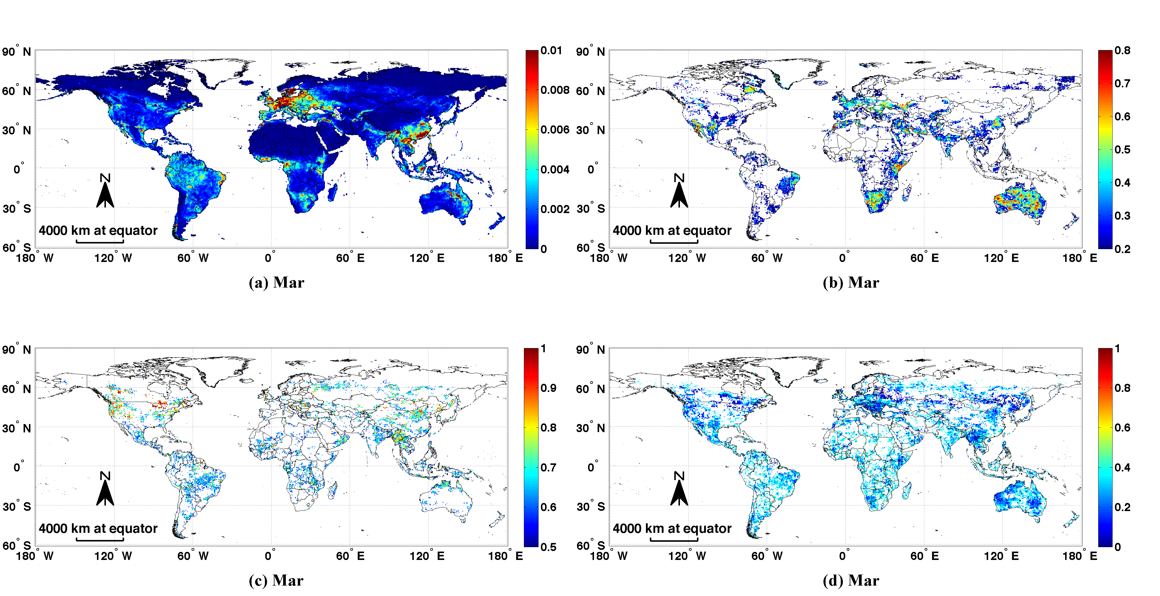

Figure S5. Cont.
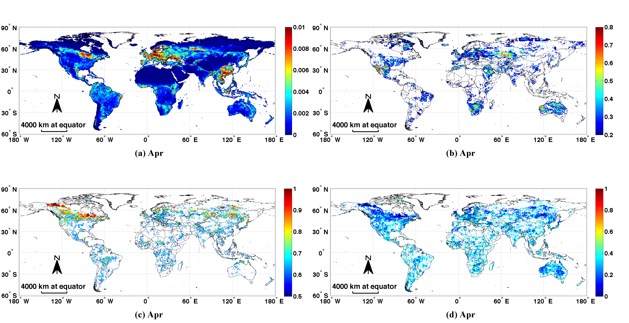

Figure S5. Cont.
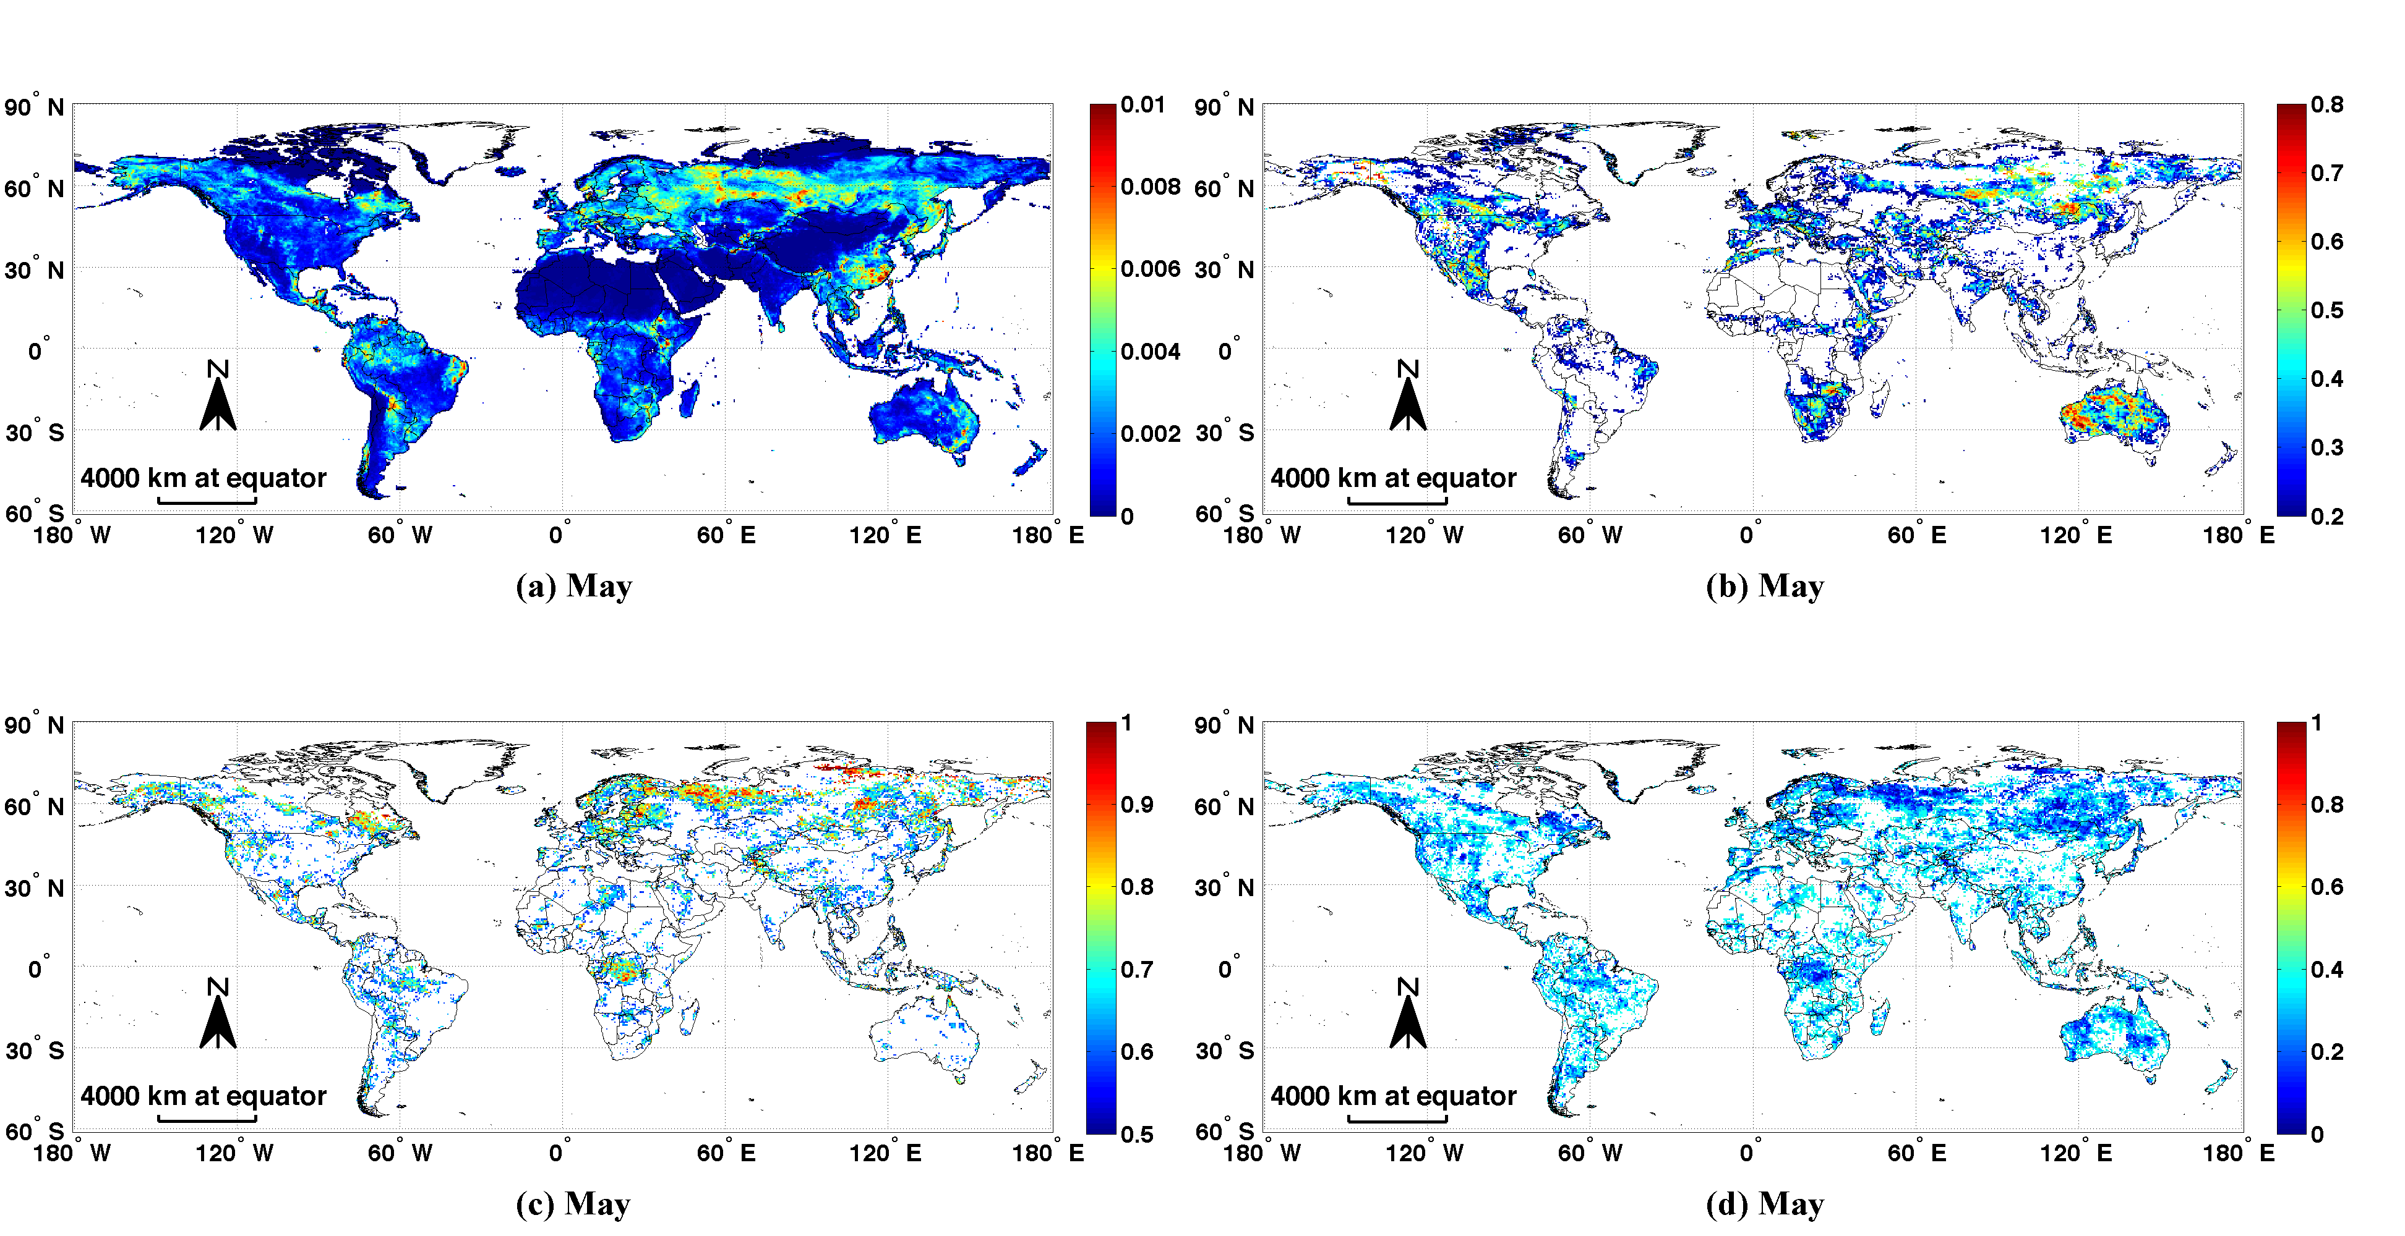

Figure S5. Cont.
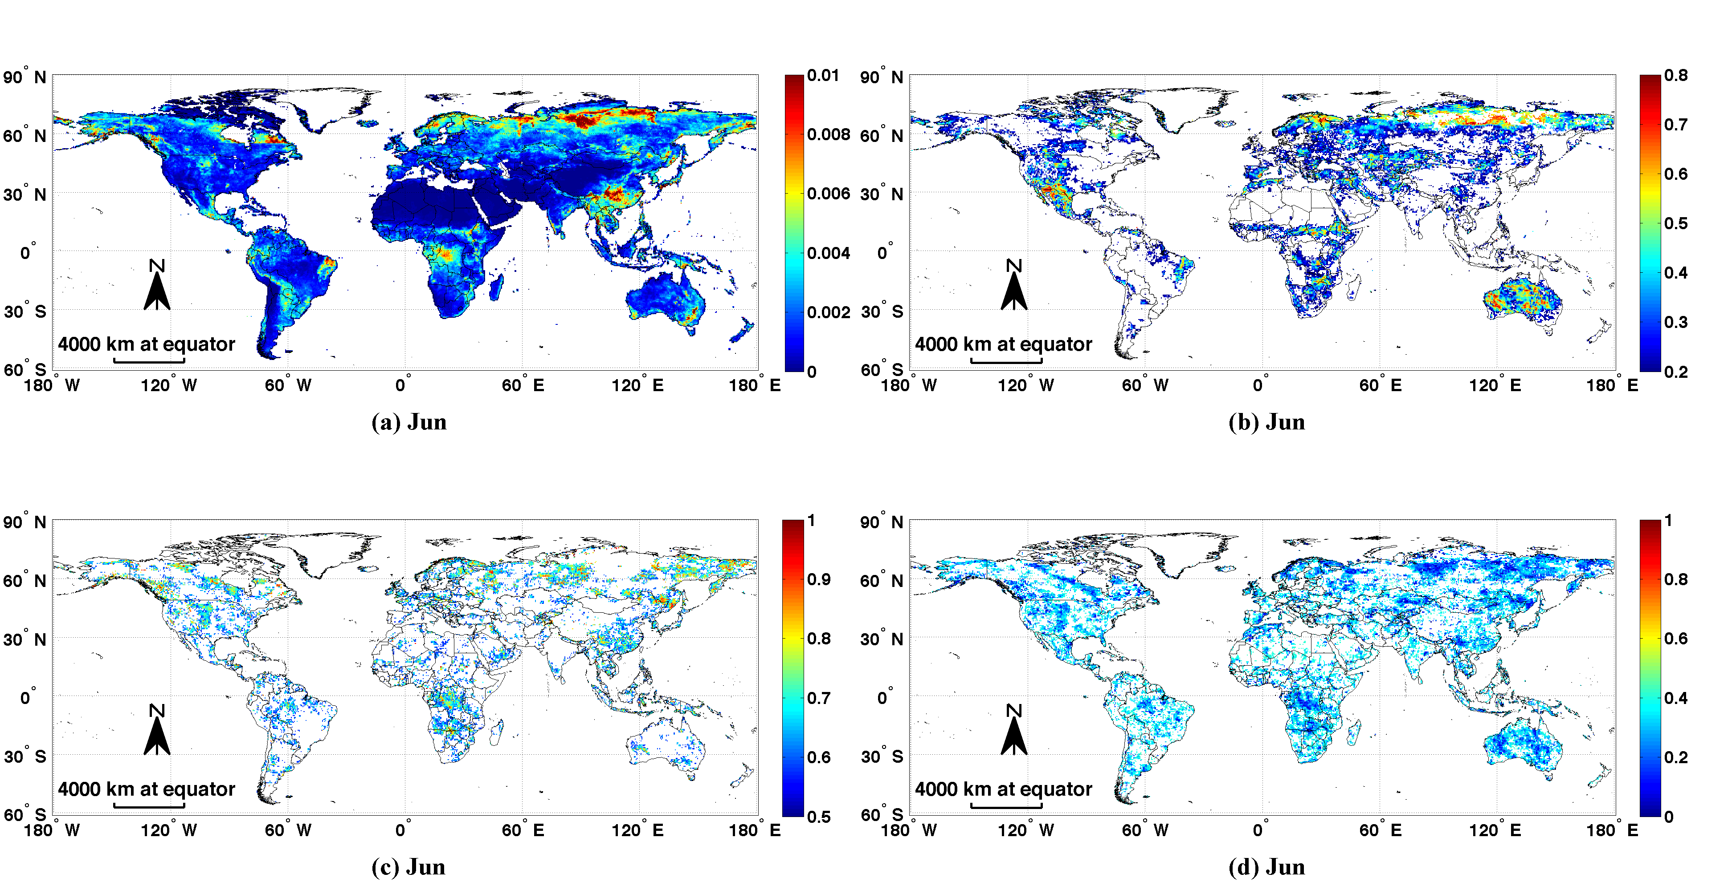

Figure S5. Cont.
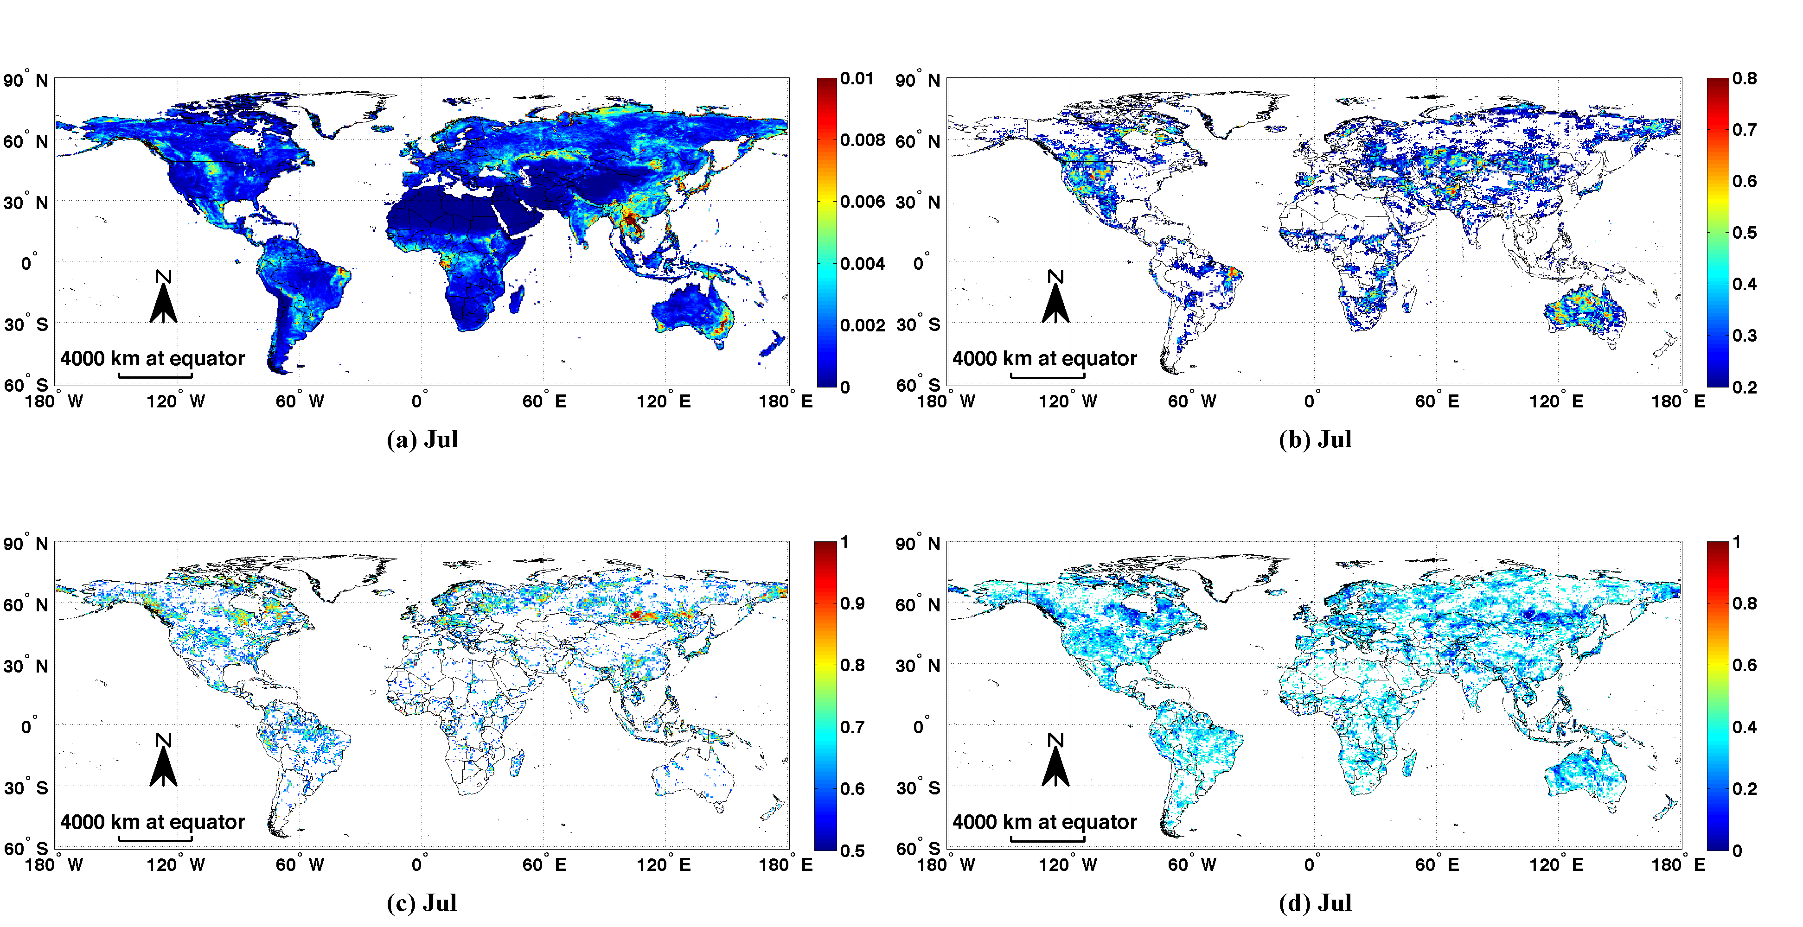

Figure S5. Cont.
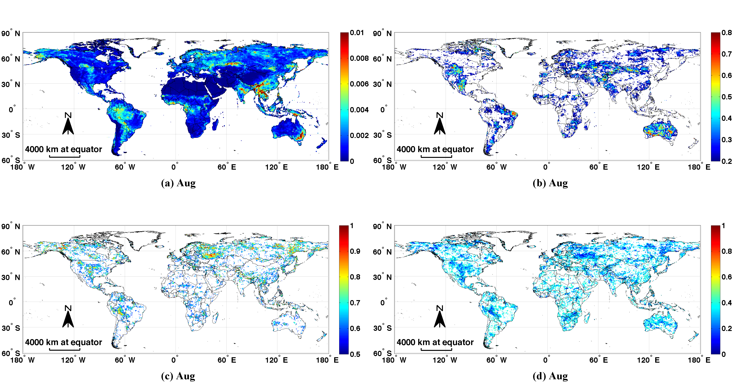

Figure S5. Cont.
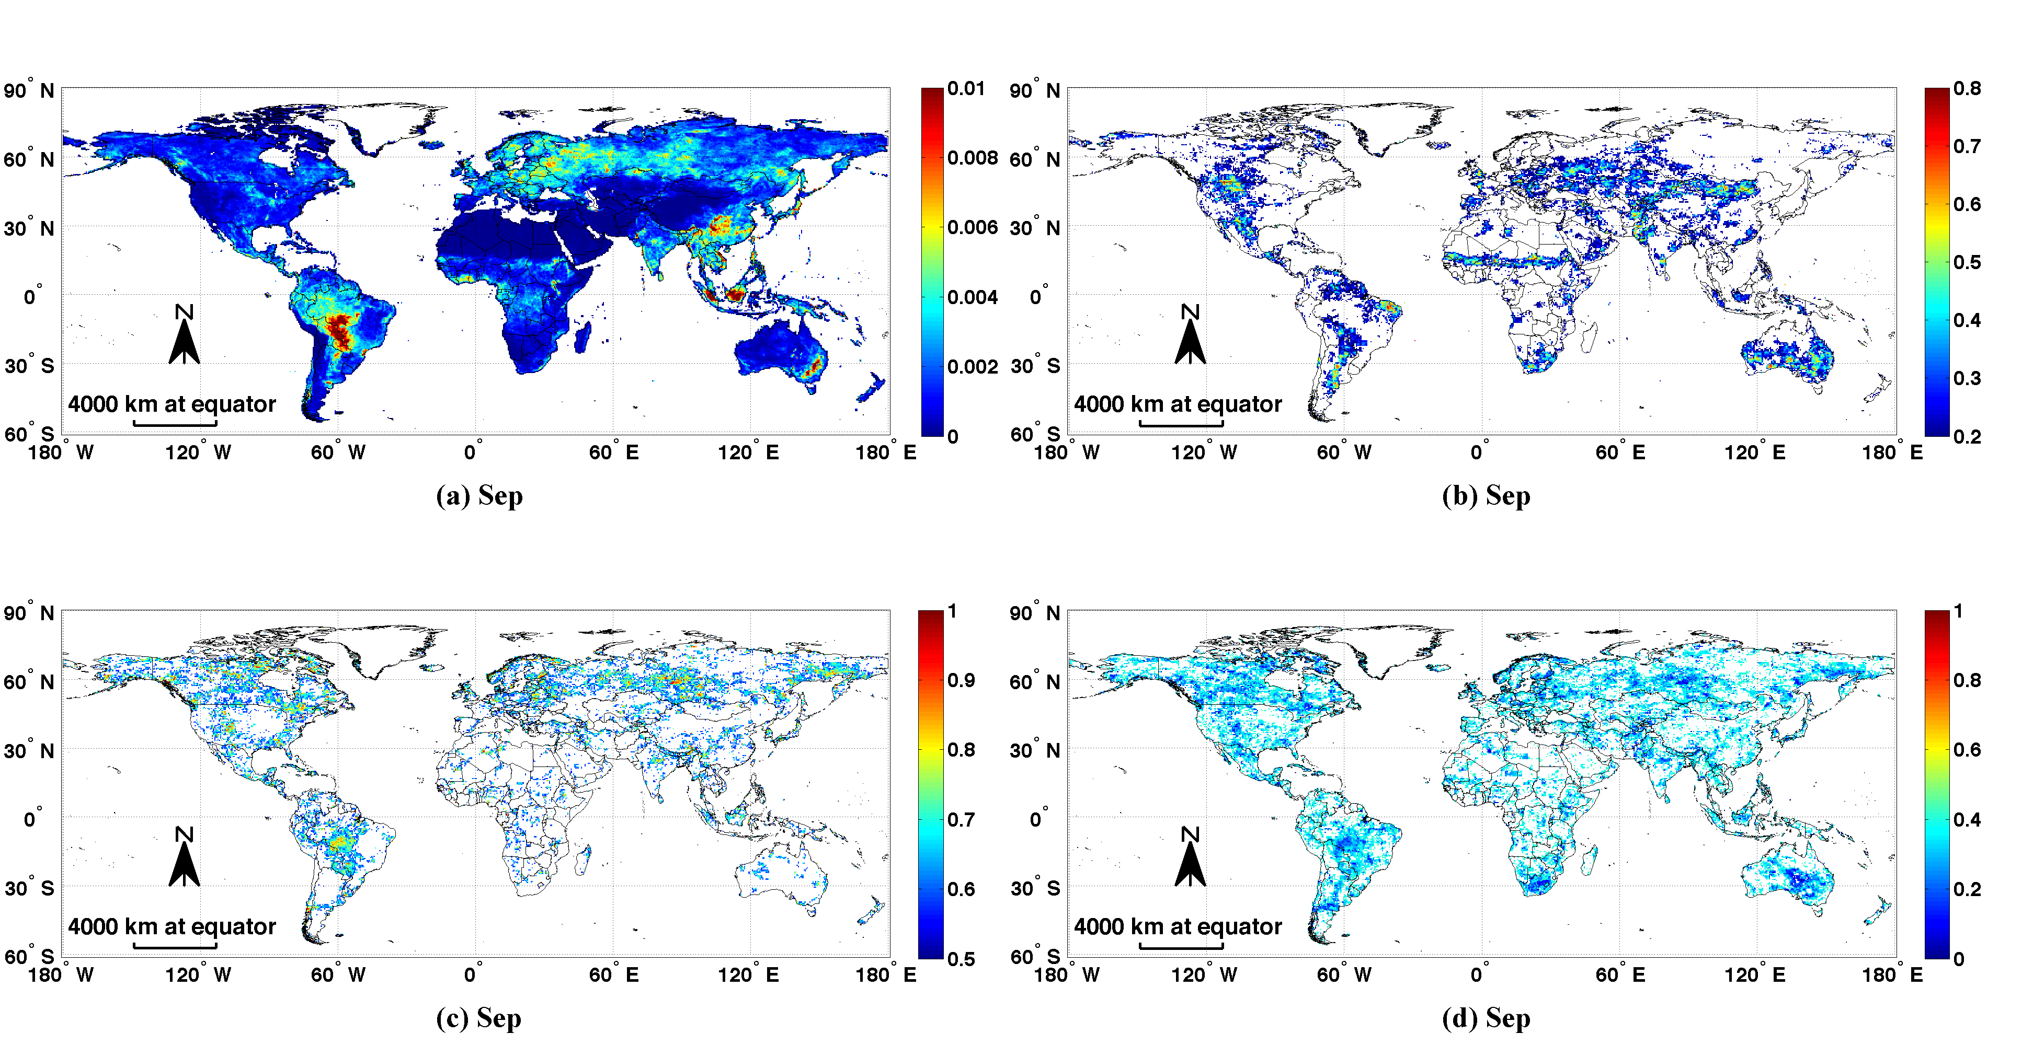

Figure S5. Cont.
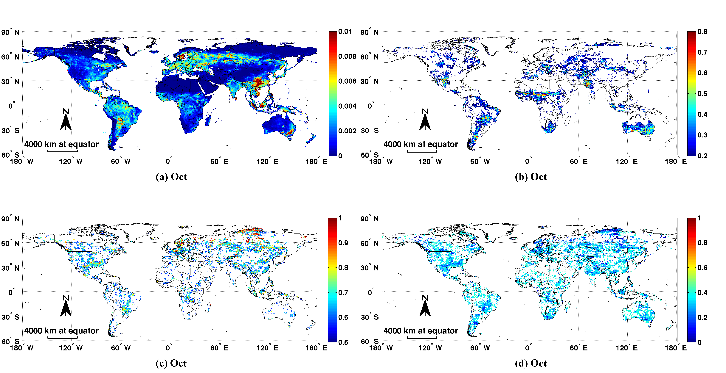

Figure S5. Cont.
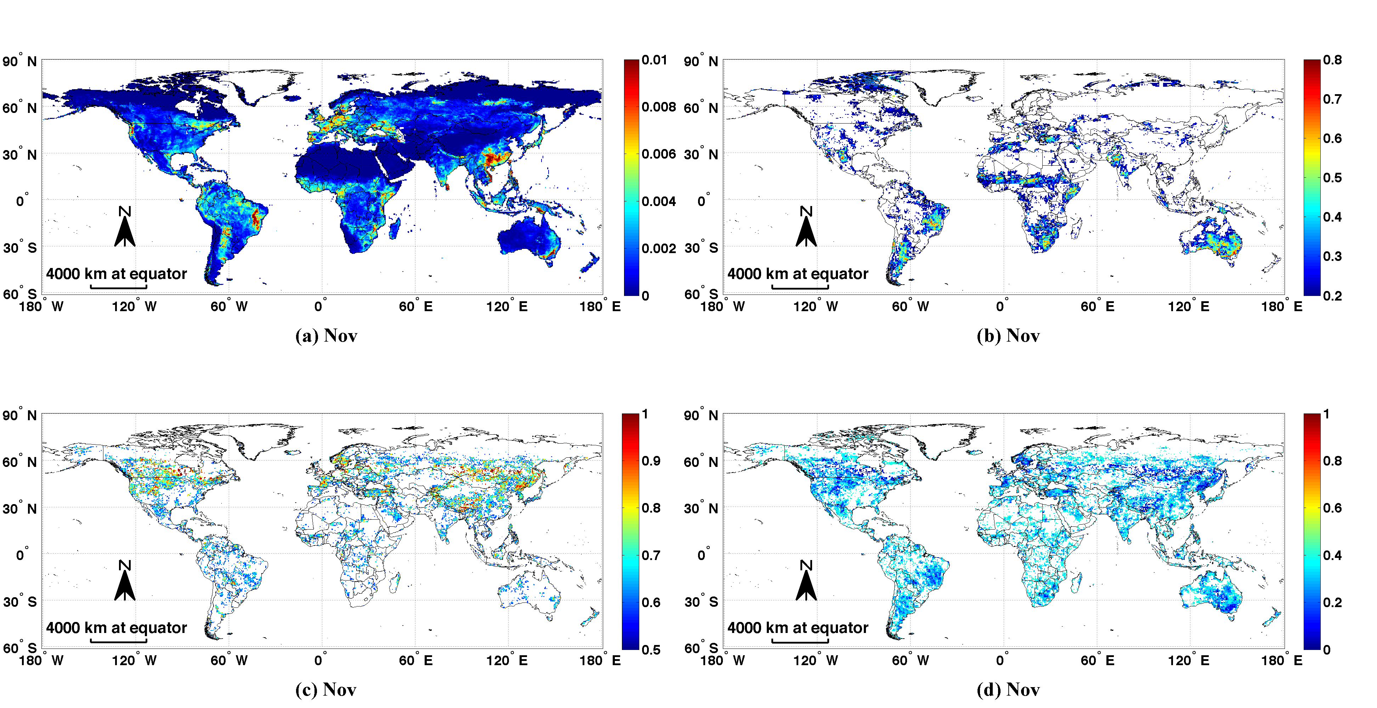

Figure S5. Cont.
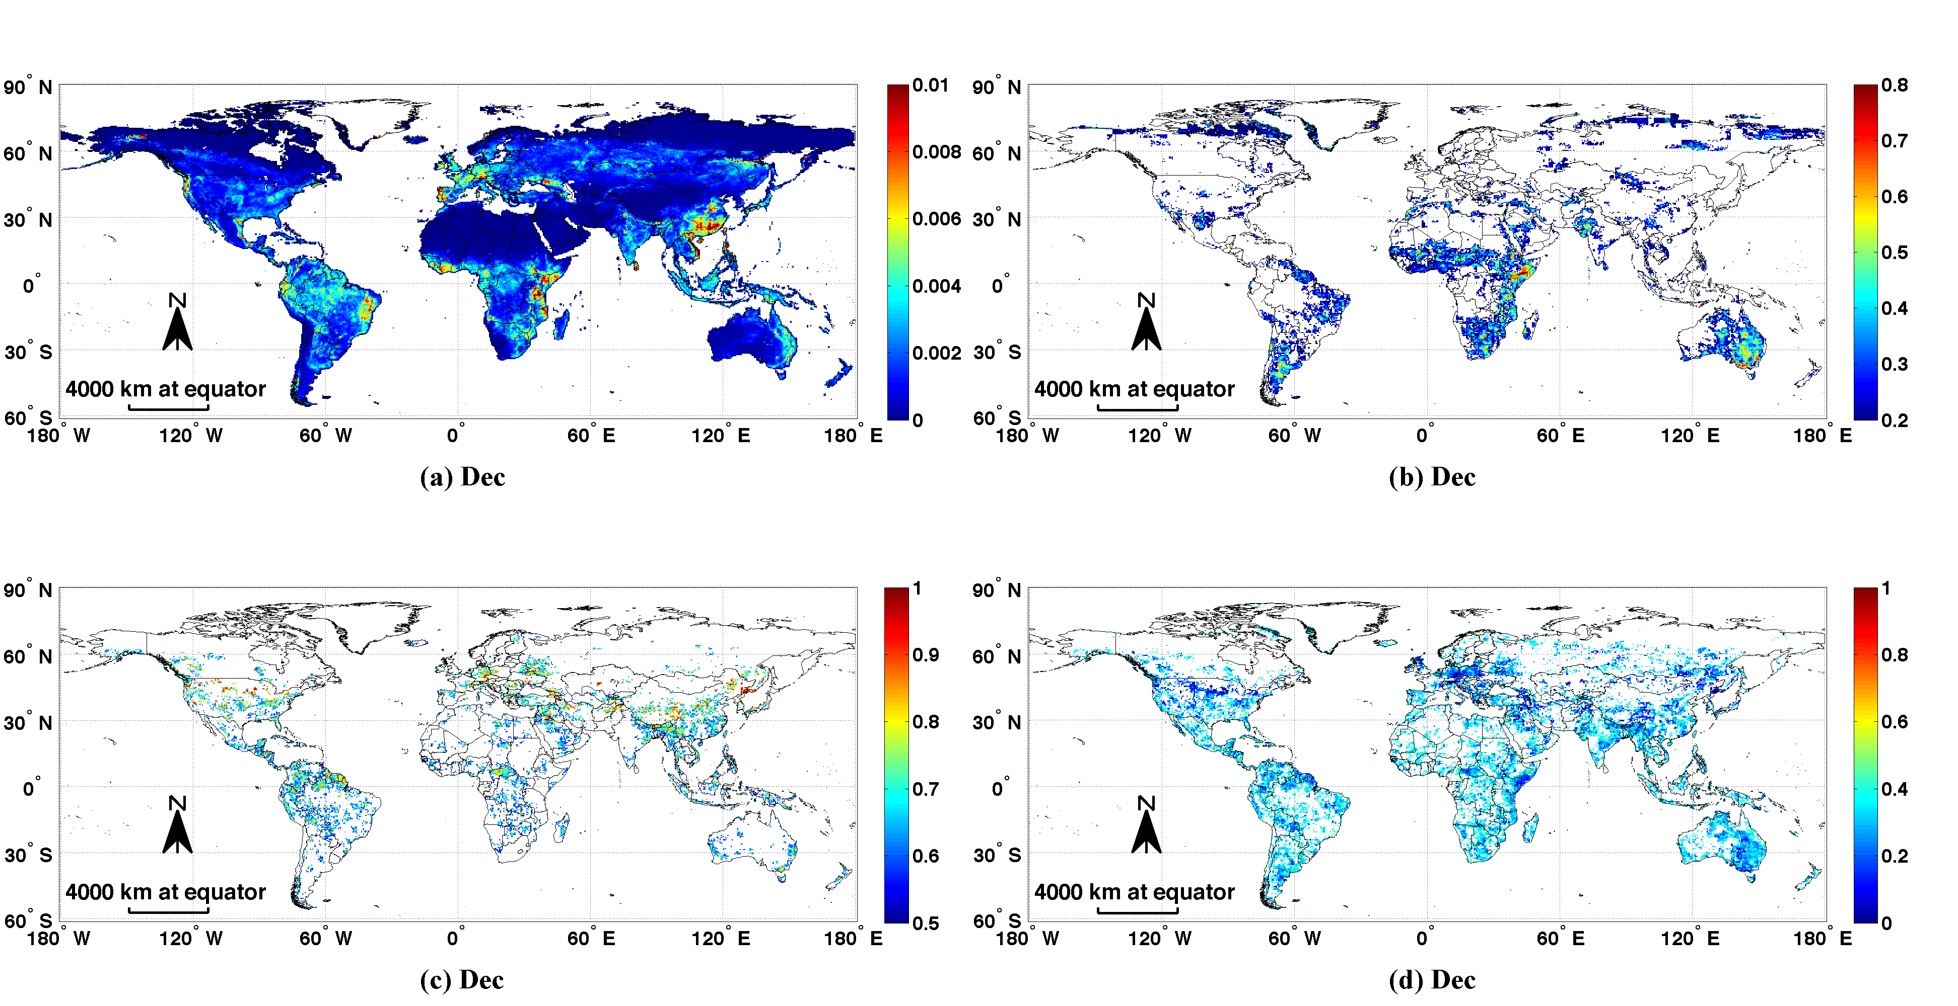
© 2013 by the authors; licensee MDPI, Basel, Switzerland. This article is an open access article distributed under the terms and conditions of the Creative Commons Attribution license (http://creativecommons.org/licenses/by/3.0/).

