OPEN ACCESS
remote sensing
ISSN 2072-4292
www.mdpi.com/journal/remotesensing
Supplementary Information
Assessing Long-Term Changes in the Beach Width of Reef Islands Based on Temporally Fragmented Remote Sensing Data. Remote Sens. 2014, 6, 6961-6987
Thomas Mann ^{1,}* and Hildegard Westphal ^{1,2}
¹ Leibniz Center for Tropical Marine Ecology, Fahrenheitstrasse 6, D-28359 Bremen, Germany;
E-Mail: hildegard.westphal@zmt-bremen.de
² Department of Geosciences, University of Bremen, D-28359 Bremen, Germany
* Author to whom correspondence should be addressed; E-Mail: thomas.mann@zmt-bremen.de;
Tel.: +49-(0)-421-2380-0132; Fax: +49-(0)-421-2380-030.

This supplementary material supports the main text as follows:

Table 1. Summary of changes in planform beach area for studied islands. Values in parantheses indicate percentage change of total beach area compared to the chronologically preceding area.
Island | Total Beach Areas (ha) |  |  |  |  |  |  | Max. Island | Max. Island | Island
Island |  |  |  |  |  |  |  | Length * | Width ** | Area ***
 | September 1943 | December 1943 | September 2003 | July 2005 | May 2008 | October 2010 | November 2012 | (km) | (km) | (ha)
Farafatu |  | 1.22 | 0.53 (−57) | 1.02 (95) | 0.09 (−91) | 0.31 (233) | 0.29 (−6) | 0.26 | 0.16 | 3.18
Kapeiatu |  | 1.17 | 0.77 (−34) | 0.91 (18) | 0.24 (−73) | 0.37 (54) | 0.32 (−15) | 0.17 | 0.07 | 0.93
Karuteke |  | 1.28 | 0.45 (−65) |  | 0.22 (−52) | 0.22 (4) |  | 0.20 | 0.41 | 3.21
Latuma |  | 0.93 | 0.31 (−67) | 0.41 (31) | 0.12 (−71) | 0.08 (−35) | 0.11 (45) | 0.15 | 0.36 | 2.09
Maturi |  | 1.17 | 0.36 (−69) | 0.97 (171) | 0.11 (−89) | 0.07 (−34) | 0.15 (114) | 0.09 | 0.41 | 1.36
NN1 |  | 0.44 | 0.29 (−34) | 0.57 (96) | 0.11 (−81) | 0.13 (16) | 0.10 (−20) | 0.06 | 0.11 | 0.33
Nukuáhare |  | 1.51 | 0.65 (−57) | 0.94 (44) | 0.23 (−76) | 0.22 (−3) | 0.18 (−19) | 0.10 | 0.47 | 1.37
Nukutoa | 2.61 | 3.21 (23) | 0.46 (−86) | 1.46 (215) | 0.35 (−76) | 0.61 (76) | 0.38 (−38) | 0.43 | 0.33 | 5.63
Nukúturua (W) |  | 0.45 | 0.45 (−1) | 0.77 (71) | 0.18 (−77) | 0.25 (42) | 0.17 (−33) | 0.09 | 0.37 | 1.05
Takú | 4.65 | 5.98 (29) | 3.07 (−49) | 4.71 (53) | 1.95 (−58) |  | 2.17 (11) | 2.00 | 0.90 | 67.46
* Longest axis of the 1943 vegetated island core parallel to the reef edge; ** Longest axis of the 1943 vegetated island core perpendicular to the reef edge;
*** Calculated from the 1943 vegetated island core.

Figure S1. (a–d) Morphological changes in planform beach area for Karuteke Island over the study period. Note the different sand spit dimensions at the edges of the island. The dashed lines represent the toe of beach. Aerial photograph (a) was provided by the Bernice Pauahi Bishop Museum (www.bishopmuseum.org), satellite images (b–d) are © DigitalGlobe, supplied by European Space Imaging.
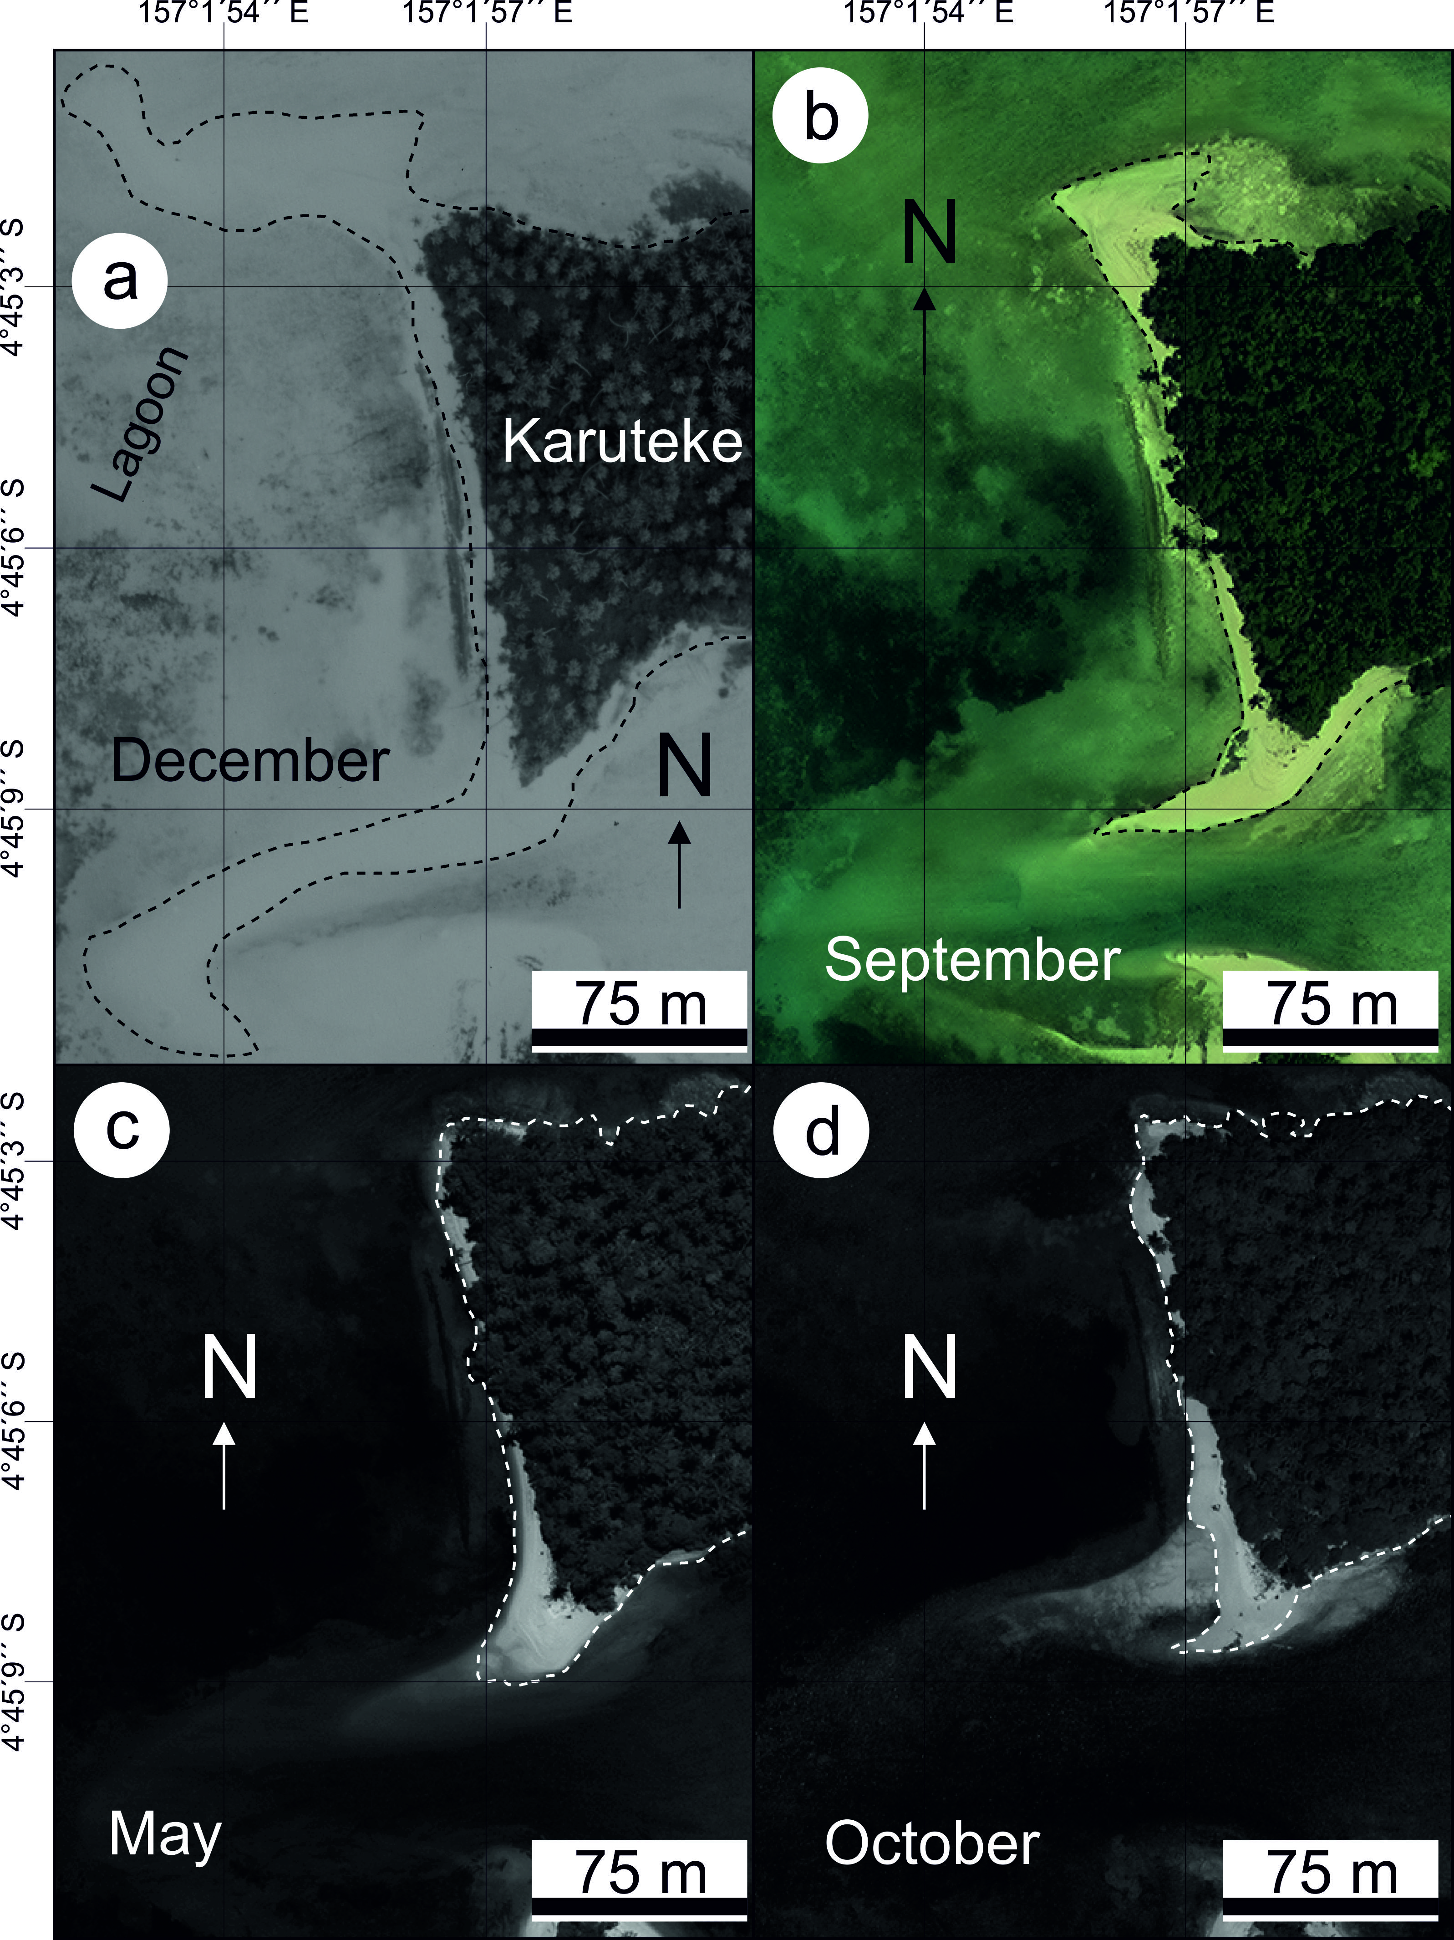
© 2014 by the authors; licensee MDPI, Basel, Switzerland. This article is an open access article distributed under the terms and conditions of the Creative Commons Attribution license (http://creativecommons.org/licenses/by/3.0/).

