OPEN ACCESS
sensors
ISSN 1424-8220
www.mdpi.com/journal/sensors
Supplementary Information

DNA-Based Sensor for Real-Time Measurement of the Enzymatic Activity of Human Topoisomerase I. Sensors 2013, 13, page range
Lærke Bay Marcussen ^{1,2,#}, Morten Leth Jepsen ^{1,3,#}, Emil Laust Kristoffersen ^{1,3,#},
Oskar Franch ^{1,3}, Joanna Proszek ², Yi-Ping Ho ³, Magnus Stougaard ^{2,3,}* and
Birgitta Ruth Knudsen ^{1,3,}*
¹ Department of Molecular Biology and Genetics, Aarhus University, Aarhus C 8000, Denmark;
E-Mails: laerke_bay@hotmail.com (L.B.M.); mortenlethjepsen@gmail.com (M.L.J.); emillk@mb.au.dk (E.L.K.); oskar.franch@post.au.dk (O.F.)
² Department of Pathology, Aarhus University Hospital, Aarhus C 8000, Denmark;
E-Mail: joanna.proszek@gmail.com
³ Interdisciplinary Nanoscience Center (iNANO), Aarhus University, Aarhus C 8000, Denmark;
E-Mail: megan.ypho@inano.au.dk
# These authors contributed equally to this work.
* Authors to whom correspondence should be addressed; E-Mails: magnstou@rm.dk (M.S.); brk@mb.au.dk (B.R.K.).

Contents

Figure S1. Shows a bar chart depicting the initial velocity calculated from three individual experiments where the DNA sensor was incubated with either no hTopI or 2.5 ng/μL purified hTopI (Y327F) lacking the active site tyrosine or 2.5 ng/μLwild type hTopI. The initial velocity of the wild type enzyme was normalized to 100%.
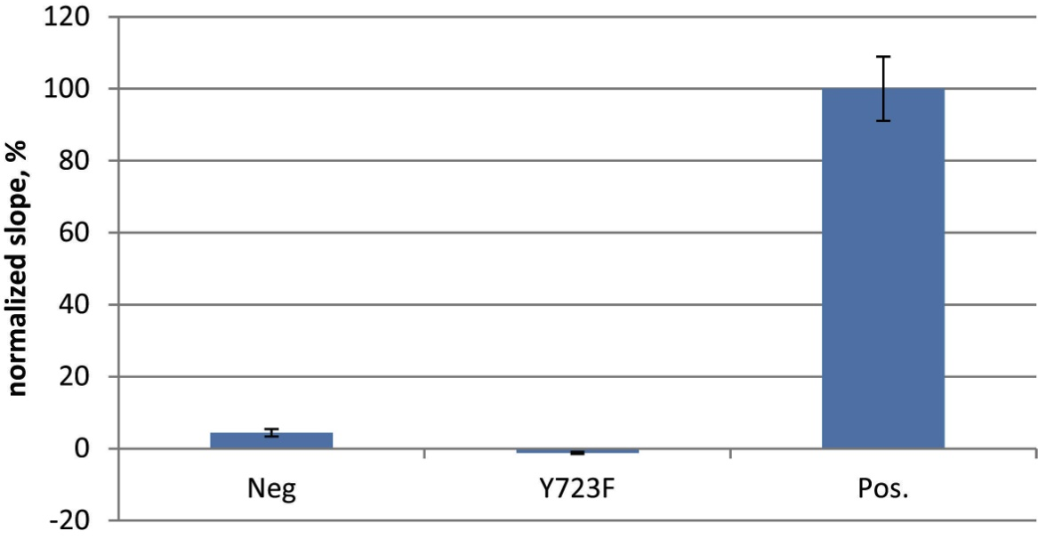

Figure S2. (A) Shows a bar chart depicting the initial velocity calculated from three individual experiments where the DNA sensor was incubated with decreasing concentrations of hTopI as indicated in the figure. (B) Shows the result of a relaxation experiment where 200 ng of supercoiled pUC19 was incubated with 2.500, 1.250, 0.625, 0.208, 0.042, 0.021, 0.008, or 0.004 ng/μL (lanes 2–9) of hTopI for 30 minutes at 37 °C in a 1× TopI buffer containing 150 mM NaCl, which is optimal for hTopI mediated relaxation. Lane 1 is a negative control with supercoiled plasmid incubated without hTopI. The lower band represents supercoiled plasmid. The upper band represents fully relaxed plasmid and the intermediate bands represent partly relaxed plasmid.
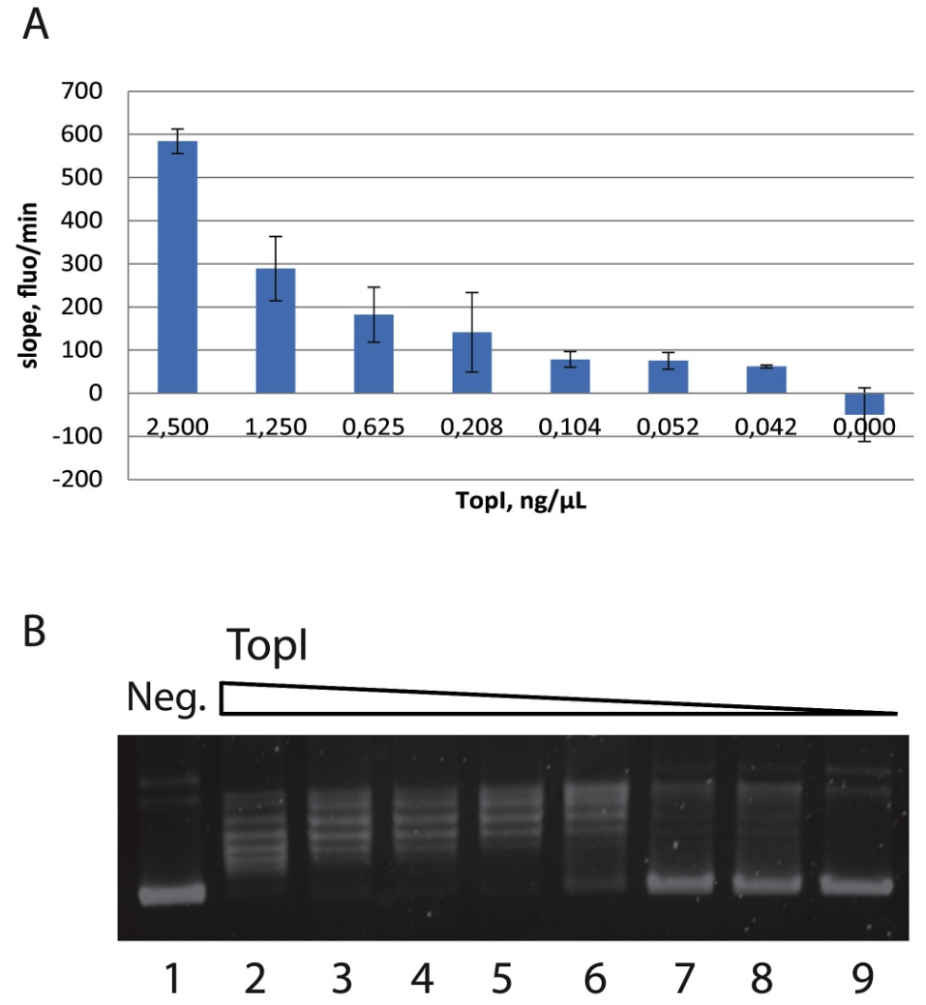
© 2013 by the authors; licensee MDPI, Basel, Switzerland. This article is an open access article distributed under the terms and conditions of the Creative Commons Attribution license (http://creativecommons.org/licenses/by/3.0/).

